**Data Analytics for LMDT Consulting Ltd**

**CASE STUDY: UAE and GERMANY**

**NAME: OLUFEMI EMMANUEL OWOLABI**

Table of Contents

1.0 Introduction 4

2.0 Environmental Analysis – PESTEL 5

2.1 PESTLE ANALYSIS FOR UNITED ARAB EMIRATES 6

2.1.1 Political 6

2.1.2 Economic Factors 8

2.1.3 Technological Factor 9

2.1.4 Social Factor 11

2.1.5 Legal and regulatory framework 13

2.1.6 Environmental 14

2.2 Germany 15

2.2.1 Political 15

2.2.2 Economic Factors 16

2.2.3 Social Factor 19

2.2.4 Technological Factor 21

2.2.5 Legal and regulatory framework 22

2.2.6 Environmental Factor 23

2.3 Porter Five Forces 25

2.3.1 Overview of Porter's Five Forces 25

2.4. Porter's Five Forces For UAE 26

2.5 Porter's Five Forces for Germany 28

3. Evaluation of the two countries 30

3.1 Evaluation of Germany 30

3.1.1 Profitability of the Management Consulting Industry in Germany 30

3.1.2 Market Growth Rate in the Service Sector in Germany 32

3.1.3 Market size of the consulting sector in Germany 36

3.1.4 Client Demand for HR Services in Germany 37

3.2 Evaluation of the United Arab Emirate 40

3.2.1 Profitability of the Service in the United Arab Emirate 40

3.2.2 Market Growth Rate in the Service Sector in the United Arab Emirate 42

3.2.3 The market size of the Consulting Sector in the United Arab Emirates 44

3.2.4 Client Demand for HR Services in the United Arab Emirates 45

3.3 The Best Destination for Expansion and Recommendation 48

4. Market Entry Strategy 49

4.1 Mergers and Acquisitions Entry Strategy in Germany 49

4.1.1 Justification of Findings 54

4.2 The top HR consulting firms in Germany for potential merger and acquisition opportunities by LMDT Consulting Ltd 55

5. Implementation of Data Analysis 56

5.1 Implementation of Data Analysis for LMDT Consulting Ltd 56

5.2 Data Analysis Role in Strategic Decision-Making 60

6. Conclusion and Recommendation 61

References 62

# 1.0 Introduction

This data-driven consultancy will help LMDT Consulting LTD in evaluating the feasibility of expanding into the United Arab Emirates or Germany, as well as choosing the most profitable market areas to focus on.

The project is structured around four main objectives: analysing the market using PESTLE and Porter's Five Forces, determining the best country and sector for expansion based on data, analysing market entry strategies, and establishing a system to monitor and analyse sales performance in the chosen market. This project will depend on a variety of data sources, including market reports, competitor analysis, and industry insights, to guide the expansion decisions. The report will focus on two markets: the United Arab Emirates (UAE) and Germany. By examining these countries' market environments, growth potential, and competitive landscapes, this project will recommend where and how LMDT Consulting Ltd should expand.

This project reflects the combination of LMDT Consulting Ltd's HR expertise, advanced Data analytics, and business strategy. Through thorough evaluation and strategic insight, this project will identify the most profitable options for LMDT Consulting Ltd's international expansion.

# 2.0 Environmental Analysis – PESTEL

The PESTLE analysis was initially introduced by Francis J. Aguilar, a professor at Harvard Business School (Frue, 2017). This tool is useful for starting a new business or entering a new market as it analyses and monitors macro-environmental factors that can have a significant impact on a company's success (Bruin, 2016).

The framework classifies the six forces as politics, economy, socio-cultural, technology, environment, and law.

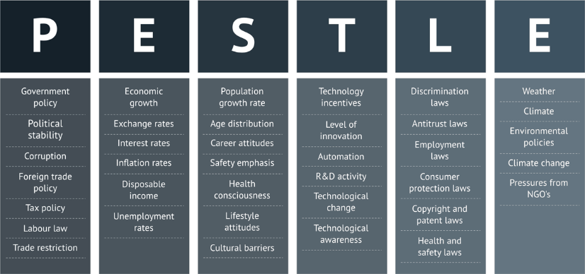

Figure 1: The Pestle Framework (Heubel, 2023).

## 2.1 PESTLE ANALYSIS FOR UNITED ARAB EMIRATES

### 2.1.1 Political

The UAE's stability outperforms that of its Arab Gulf neighbours, due to a defined presidential succession plan, low religious radicalism, and mostly resolved border conflicts (Gold, 2020). This stability attracts international investment, which boosts economic growth. The BTI Transformation Index Dashboard (2022) in Figure 2 shows the UAE's developed economy and its effective yet highly autocratic governance. The UAE receives an 8 out of 10 for economic change, ranking 14th out of 137 countries, and a 6.55 out of 100 for governance, placing it 15th globally. The government system operates with great efficacy and minimum friction, with little desire for significant political reforms because the people are content with the political decision-making process.

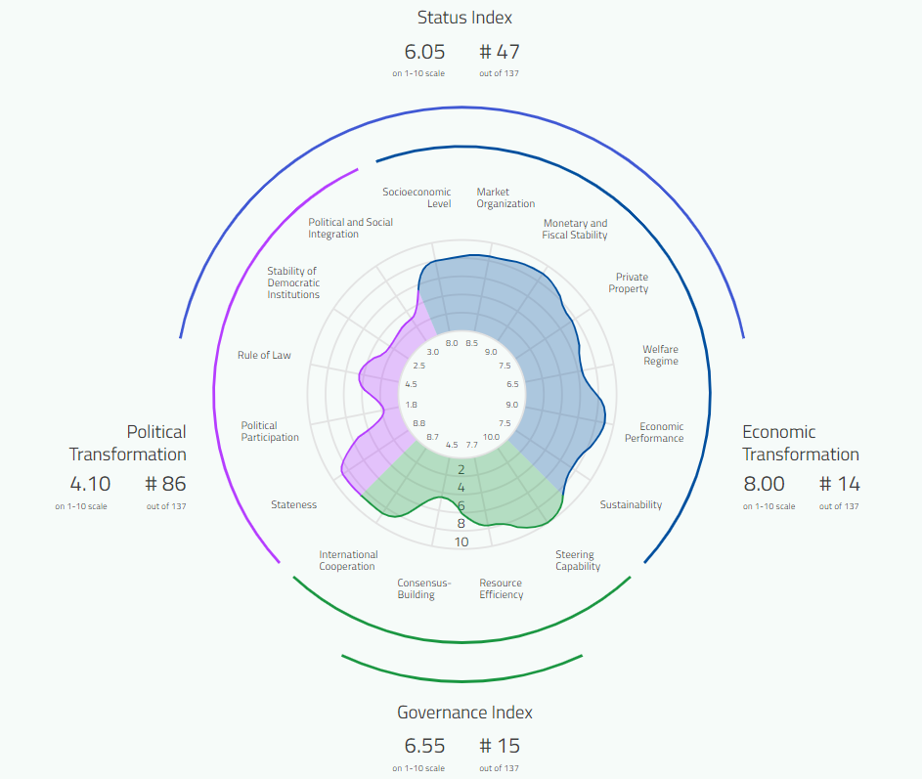

Figure 2: BTI Dashboard (BTI Transformation Index Dashboard 2022).

A stable political environment is more likely to recruit skilled labour, resulting in brain gain rather than brain drain (Fastercapital, 2024b). This situation provides an excellent opportunity for LMDT Consulting LTD to implement its Strategic Workforce Planning, Talent Acquisition, and Recruitment services. LMDT Consulting LTD is well-positioned to help businesses develop plans to capitalise on the influx of qualified individuals lured to the UAE's favourable working environment.

### 2.1.2 Economic Factors

**Inflation**

Since 2009, the UAE has had a single-digit inflation rate. Notably, the rate increased marginally to 3.60% in January 2024 from 3.27% in December 2023. The UAE's average inflation rate from 1990 to 2024 was 1.66%, peaking at 12.30% in December 2008 and falling to -2.71% in May 2020 (IMF, 2024). Currently, the inflation rate is 2.3%.

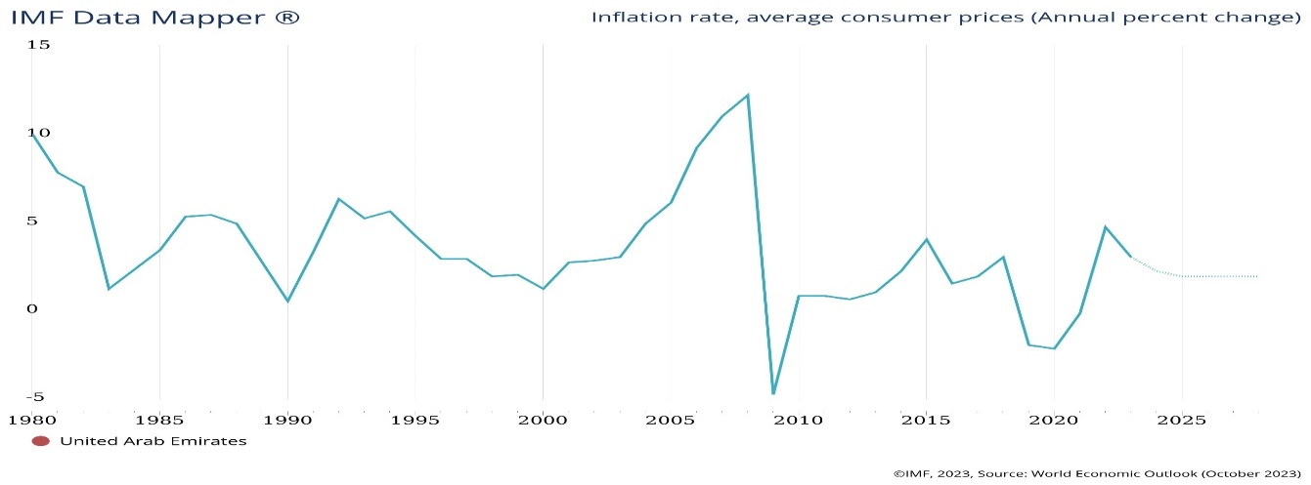

Figure 3: Inflation Rate (IMF 2024).

Between 2000 and 2018, UAE consumer price inflation was greater than the GCC average, but it declined compared to other GCC members during the next three years (Puri-Mirza, 2024). Salaries in the UAE are expected to climb by 4.1% on average in 2024, driven by non-oil sector development and rising OPEC+ oil output (Enterprise, 2024; Cooper Fitch, 2024). Furthermore, a Mercer analysis shows that inflation and exchange rate fluctuations have a major influence on the incomes and savings of expatriate employees in the UAE (Release, 2023).

The HR environment is changing, with 16.3% of UAE companies aiming to expand their workforce and 11.4% expecting to keep more than half of their employees (Cooper Fitch, 2024). This dynamic market allows LMDT Consulting LTD to help UAE businesses navigate these changes by offering specialised services such as pay research, benefits strategy, and international employee management.

### 2.1.3 Technological Factor

The Ministry of Industry and Advanced Technology (MoIAT) has spearheaded innovation, technological advancement, and sustainable industry development. By 2031, it aims to increase science and technology R&D to 1.5% of GDP (Service, 2023). Also, Operation 300 billion intends to boost industrial output by AED 300 billion ($81.6 billion) over five years by helping SMEs and startups embrace new technology (UAE, 2023). UAE start-ups are flourishing, with over 40% being technology-driven (DTEC, 2023). The UAE ICT market was worth US$ 36.13 billion in 2022 and is expected to rise 12.77% to US$ 65.90 billion by 2027. UAE ICT providers are expected to earn US$ 293.95 billion from 2022 to 2027 (GlobalData, 2023).

Iyer (2023) stated that the HR industry in the UAE is keen to adopt technology at a rapid pace. In 2024, HR professionals will be able to make data-driven decisions and improve operational efficiency through cloud-based solutions, automation, and data analytics (Iyer, 2023). Expanding into the UAE market allows LMDT Consulting Ltd. to provide HRM services to the growing technology sector. LMDT could turn into a key partner for UAE IT companies by focusing on start-ups, talent management, compliance, and HR technology implementation.

### 2.1.4 Social Factor

**Population**

O'Neill (2024) stated that the UAE population in 2024 is 10.24 million. In 2024, GMI conducted a study that found that the total population of expatriate people in the UAE in 2024 was 9.06 million (Global Media Insight, 2022). The total number of males in the UAE in 2024 is 7.07 million, while the total number of females is 3.17 million.

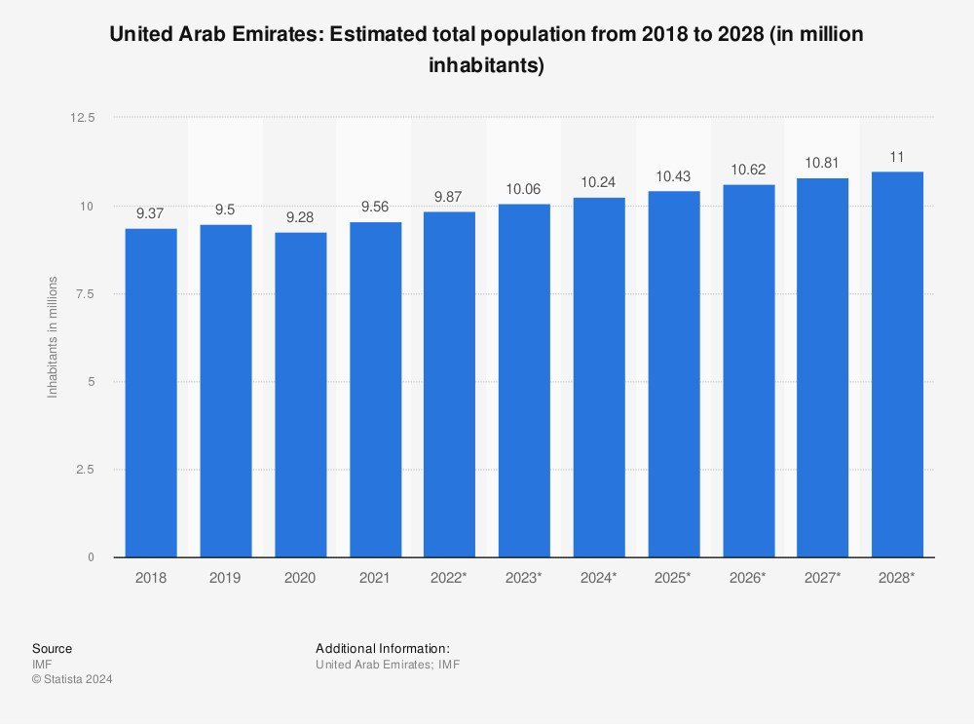

Figure 4: UAE Population (Statista, 2024)

The UAE has witnessed drastic demographic shifts in the past decade. Due to the growth, tourism, and global prominence of UAE cities like Abu Dhabi and Dubai, the population has expanded by 6 million over the past decade. The UAE's growing population and expatriate influx is an opportunity for LMDT Consulting Ltd to offer services such as talent acquisition and strategy workforce planning. Also, as the country evolves, startups in the United Arab Emirates (UAE) are being asked to take a proactive approach to ensure compliance with the government's expanding 'Emiratisation' requirements (Pinsent Masons, 2023). This is another opportunity for LMDT Consulting Ltd to offer services such as the provision of career development opportunities to support local employee growth and retention and the implementation of training and development programs to enhance employee skills and competencies.

### 2.1.5 Legal and regulatory framework

Emiratisation is the UAE government's plan to increase the number of UAE nationals employed in private companies. One of the most major changes to the UAE Emiratisation Law 2023 is the implementation of a new quota system for private-sector Emirati employers. The quota system mandates firms to hire a particular percentage of UAE nationals based on the size and activity of their company (Khaleeli, 2024). The quota varies by sector and number of employees, ranging from 2% to 60%. The new UAE Emiratisation Law 2024 requires private-sector businesses (50+ employees) to achieve a minimum of 2% year-on-year increase in their Emirati workforce for skilled positions (Muqeeth, 2022). The Emiratisation Law 2023 also includes new incentives for businesses established in Abu Dhabi or the UAE that surpass their quotas or hire nationals in high-demand occupations. These incentives include exemptions from taxes, subsidies, preferential treatment in government tenders, and access to training and development programmes.

There is an opportunity for LMDT Consulting Ltd in terms of strategic entry and operational flexibility. The choice between establishing in the UAE mainland or a Free Zone provides flexibility in terms of operational and ownership structure. Also, there is an opportunity for LMDT Consulting Ltd to help companies develop targeted strategies to attract, retain, and develop UAE national talent to meet these legal requirements.

### 2.1.6 Environmental

**Sustainability**

Sustainability is a major focus for UAE organizations, driven by the government's commitment to climate action, which includes financing renewable energy projects and achieving net-zero emissions by 2050 (Bhat, 2022). The UAE has seen significant growth in the number of professionals entering the region with expertise in environmental matters, with a 26% increase (Al Helou, 2023). Global recruitment agency Robert Walters conducted a survey that revealed a significant demand for such individuals in the industry, resulting in an increased pool of talent. As a result, the UAE presently has over 35,000 professionals who prioritise sustainability and environmental compliance (Al Helou, 2023).

The increased need for sustainability-focused professionals presents a clear opportunity for HR departments to take the lead in recruiting and developing talent capable of driving sustainable business practices. This is an opportunity for LMDT Consulting Ltd, which can help businesses align with the UAE's sustainability vision by providing innovative HR practices, talent management, leadership development, and compliance advisory services.

## 2.2 Germany

### 2.2.1 Political

The continuous crisis caused by Russia's invasion of Ukraine has resulted in the biggest refugee movement in Europe since World War II. According to the Federal Office for Migration and Refugees (2022), more than one million people have sought asylum in Germany since the crisis began. This surge has put a significant burden on the German labour market, which is unlikely to find a long-term solution to workforce issues through the integration of Ukrainian refugees. According to the United Nations High Commissioner for Refugees (UNHCR), as of February 15, 1,055,323 Ukrainian refugees had entered Germany (Ward-Glenton, 2023).

According to a survey by the EWL Foundation for Supporting Migrants on the Labour Market, 22% of 400 participants chose Germany as their refuge because of perceived employment opportunities (Bryzek, 2023). Despite having welcomed nearly a million Ukrainian refugees over the last two years, just 214,000 people were employed by the end of 2023 (Kinkartz, 2024).

The significant number of Ukrainian migrants has significantly increased the need for human resource services in Germany. LMDT Consulting is well-positioned to meet this demand by providing specialised workforce integration services, as well as training and development programmes tailored exclusively to refugees and other immigrant groups.

## 2.2.2 Economic Factors

**Unemployment Rate**

Germany's unemployment rate has climbed for the 14th time in a row, with the number of unemployed rising by 11,000 to 2.713 million. Also, there was a large year-on-year increase of 190 thousand unemployed people. Regional differences are noticeable, with Bremen (11.0%) and Berlin (9.5%) having the highest unemployment rates, while Bayern (3.5%) and Baden-Württemberg (4.1%) have the lowest (Bundesagentur für Arbeit, 2024).

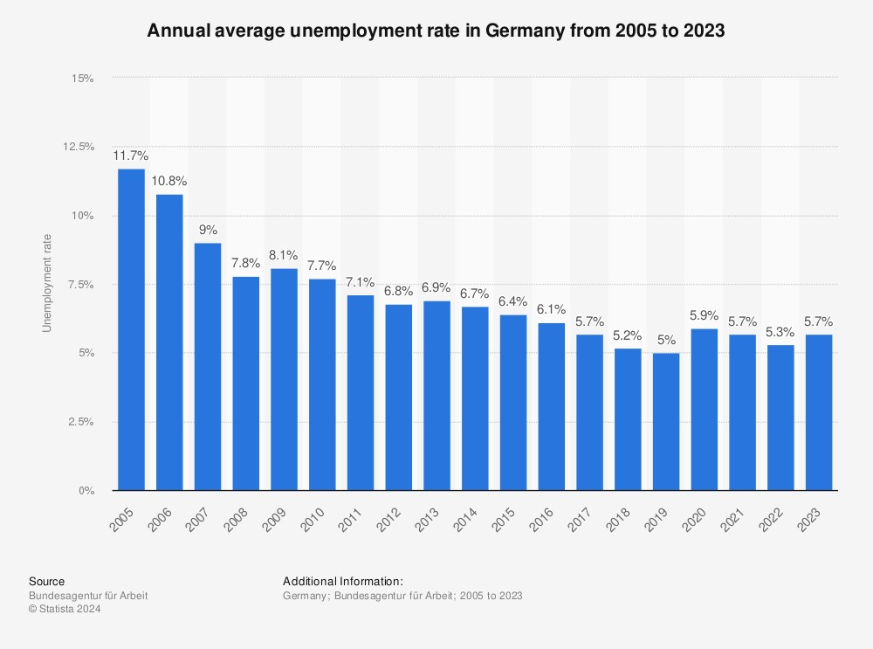

Figure 5: Annual Average Unemployment Rate in Germany (Bundesagentur für Arbeit, 2023)

According to the Federal Labour Office, Germany's overall unemployment rate increased slightly in November to 5.9%, up from 5.8% in October. This trend is viewed as part of a larger problem—a shortage of competent workers, which poses a substantial threat to the strength of Germany's labour market. According to Labour Minister Hubertus Heil's projections, there will be a seven million labour shortfall by 2035, requiring an annual recruitment of 400,000 people from outside the EU (País, 2023; Hockenos, 2023). Immigration laws have recently been changed to make it easier for non-EU citizens to integrate into employment.

LMDT Consulting LTD, with its expertise in HRM consultancy, can address this skilled worker gap. The firm can provide essential services in strategic workforce planning and talent acquisition, particularly as Germany seeks to fill a projected annual need for 400,000 recruits from outside the EU.

### 2.2.3 Social Factor

**Population**

Germany's growth is being hindered by an ageing society, particularly the fall in the working-age population (WAP, people aged 15-66), which adds to skill shortages and productivity losses (Zimmermann, Sievert, and Suwalski, 2023). As a result, the German economy seems to be struggling with vacant positions and a shortage of young applicants in the future. In 2020, approximately 30,600 vacant apprenticeship positions were registered (Davies, 2023). The lack of applicants may eventually result in a less productive German economy. Small and medium-sized businesses, as well as the automotive industry, which is the backbone of the German economy, are currently struggling to find workers to fill new roles or train replacements for their ageing workforce (Davies, 2023).

Germany's ageing population and skill shortages create demand for HR services such as talent acquisition, retention, and workforce development. This provides an opportunity for LMDT Consulting Ltd to position itself as a strategic partner to businesses facing recruitment issues, providing innovative solutions to attract and retain skilled employees. LMDT Consulting Ltd also has the opportunity to deliver vocational training and development programmes.

### 2.2.4 Technological Factor

Digital transformation is more than just investing in new technology or digitising tasks; it transforms business models, organisational culture, and value chains, profoundly changing how businesses operate (Kiron and Spindel, 2019). Using Big Data, digital work platforms have been found to dramatically improve HR performance in talent management, increasing productivity by 9% and lowering expenses by 7% while also raising employee engagement and satisfaction (Larkin and Hystad, 2017; Lund et al., 2016).

By 2030, digital technologies are expected to boost Germany's GDP by €1.25 trillion and generate 1.3 million new employment (Accenture, 2015). With more than 40% of HR managers confirming the effectiveness of digital recruitment tools (Statista Research Department, 2022), these technologies are increasingly being used for recruiting and staffing, greatly simplifying hiring and skill analysis (DiRomualdo et al., 2018).

LMDT Consulting Ltd is well-positioned to support German tech startups by capitalising on large government investments in technology and digital transformation programs. The demand for HR technology integration is likely to rise as the use of digital technologies for HR Management in Germany increases.

### 2.2.5 Legal and regulatory framework

Germany's labour laws are experiencing significant changes that will affect every company and employee. In 2024, Germany implemented a major labour law change, boosting the minimum wage from 12.00 euros per hour to 12.41 euros and increasing the income threshold for mini-jobs to 538 euros per month (BDO, 2023). This policy intends to raise the living standards of low-income workers while also promoting financial stability. As a result, firms must change their compensation structures to meet the new minimum wage requirements (Gonex Global HR Services, 2024). Furthermore, changes to compensation structure, budget planning, staff communication, and performance evaluation are required.

Another notable legal reform is the second stage of the new Immigration Act for Skilled Individuals, which takes effect on March 1, 2024, and facilitates the hiring of skilled individuals from outside the EU (Braeckeler-Kogel and Rehner, 2024).

These developments create an opportunity for LMDT Consulting Ltd. The new minimum wage requirements encourage businesses to rethink their salary structures, budget planning, and performance reviews. LMDT Consulting Ltd may provide valuable compensation, benefits, compliance, and risk management services to help businesses adjust to these changes and improve their ability to attract and manage foreign talent.

### 2.2.6 Environmental Factor

**Sustainability**

Germany's law requires reaching carbon neutrality by 2030, which encourages innovation and environmental efforts (Behrens, 2022). Environmental sustainability is becoming an intrinsic part of corporate plans, closely linked to corporate social responsibility (Dron et al., 2018). Green human resource management (GHRM) is emerging as a critical component of sustainable HR strategy, including employer branding, recruitment, training, and health management with an emphasis on environmental sustainability (Hornung, 2020; Renwick et al., 2013). HR strategies are critical to accomplishing these sustainability objectives, particularly in hiring and developing specialists with the requisite environmental skills.

This emphasis on sustainability skills creates considerable opportunity in the HR industry. LMDT Consulting Ltd, by leveraging these competencies in recruitment and employee development, can help German businesses improve their workforce capabilities to drive sustainability innovations, align with national goals, and gain a competitive advantage in an environmentally conscious market.

## 2.3 Porter Five Forces

### 2.3.1 Overview of Porter's Five Forces

The Porter Five Forces framework provides organizations with valuable information about the competitive dynamics within an industry, identifying potential risks and opportunities (Goyal, 2021; Alonso, 2023).

Figure 6: Porter’s Five Forces (Debruin, 2016)

## 2.4. Porter's Five Forces For UAE

**Threat from new entrants**

The UAE's HR industry has seen a significant increase in investment, with GulfTalent reporting a 37% increase in HR technology investment, highlighting companies' growing reliance on HR practices to drive business growth. However, entering the UAE's HR sector is difficult due to stringent employment regulations governed by the Labour Law, which necessitate compliance to protect employee rights. HR managers play an important role in enforcing these laws and fostering positive workplace cultures. As a result, understanding regulatory requirements is critical to success in the UAE human resources industry (Akrivia, 2023). As a result, the UAE HR sector has the potential to expand due to the regulatory complexities and competitive dynamics.

**Buyer Power**

Due to there being so many HR firms in the UAE particularly in major business hubs such as Dubai, Abu Dhabi, Sharjah, and Ras Al Khaimah, they have some bargaining power and can negotiate contracts there (Khassawneh and Abaker, 2022). To capitalize on this situation, HR firms must offer value-added services such as specialised knowledge in tech hiring or effective HR solutions (Khassawneh and Abaker, 2022).

HR organisations such as LMDT Consulting can attract and retain clients in this competitive market by providing tailored solutions and specialised services.

**Supplier Bargaining Power**

Suppliers to HR companies in the UAE, such as job portals, software providers, and training institutions, may have moderate negotiating power. However, forming strong alliances with suppliers and making strategic investments can help reduce supplier influence while improving operational effectiveness.

**Substitute Products or Services**

While traditional recruitment and HR management methods are available, tech companies frequently prefer customized HR services that are tailored to their needs. To differentiate itself from competitors, the LMDT Consulting LTD Company must demonstrate its ability to provide distinctive value propositions such as recruiters with advanced technological skills, data-driven talent analytics, or AI-powered HR solutions such as Nathan HR (Gulf, 2023).

**Competitive Rivalry**

In the United Arab Emirates, where technology and innovation are of utmost importance, the human resources industry faces fierce competition, particularly in the field of technology recruitment from competitors such as Fletcher Piccolo Associates, Hyperlynx, Eagleye Hr Consultants (Williams, 2023; Themanifest, 2024). To maintain a prominent position in this highly competitive industry, an HR firm such as LMDT must establish a strong brand, provide exceptional service, and constantly improve its recruitment methods.

## 2.5 Porter's Five Forces for Germany

**Threat of New Entrants**

Germany's strong technological ecosystem, particularly in cities such as Berlin, Munich, and Hamburg, attracts entrepreneurs and investors, posing challenges for HR firms like LMDT Consulting. These challenges include increased competition, compliance with stringent regulations, and established players such as Roberts Walter, and Avominds who have an overall rating of 5.0 in terms of value and service excellence in the HR Consulting sector in Germany (Frey, 2023; (Rykov, 2024); (The Manifest, 2024). LMDT Consulting Ltd can counteract the threats through specialised tech recruitment, local labour law expertise, or novel HR technology solutions services.

**Buyers' Bargaining Power**

German technology companies are discerning HR service buyers, with high expectations for quality and efficiency. Because of the large number of HR service providers such as Personio, Staffbase, Workmotion, and Heyjobs, they have significant bargaining power (Cave, 2022). To retain customers and mitigate the impact of price cuts, LMDT Consulting must demonstrate its ability to provide customized solutions, prompt customer service, and additional services.

**Supplier Bargaining Power**

Suppliers to German HR firms, such as recruitment platforms and software vendors, possess moderate power. However, the market is relatively advanced and characterized by intense competition. Strategic alliances with suppliers, as well as technological investments to optimise HR processes, have the potential to reduce reliance and mitigate supplier influence.

**Threat of Substitute Products**

While traditional HR methods are available, tech companies in Germany frequently choose specialised HR services that align with their innovative culture and digital transformation initiatives (Galinié, 2019). To compete, LMDT consulting must constantly introduce new and innovative services, use cutting-edge technology in recruitment and HR management processes, and prioritise its understanding of the unique needs of technology companies.

**Competitive Rivalry**

Germany has a highly competitive business environment, particularly in the technology sector. HR firms compete fiercely for tech talent. To succeed, the HR firm must establish a strong brand presence, gain a thorough understanding of the local tech market, and offer superior recruitment solutions backed by cutting-edge technology and exceptional service (Harnham, 2021).

# 3. Evaluation of the two countries

## 3.1 Evaluation of Germany

### 3.1.1 Profitability of the Management Consulting Industry in Germany

The International Trade Administration (2022) ranks Germany as the world's fourth-largest economy, accounting for 24.9% of the EU's GDP. With a population of 84.3 million, it is Europe's largest consumer market (Noah, 2024). Figure (7) of the BDU 2023 report shows that Germany's consulting market revenue will be around €43.7 billion in 2022. This graph shows the management consulting sector's earnings from 2001 to 2022, with a consistent increase from €12.9 billion in 2001 to a peak in 2022, followed by significant growth after 2013.

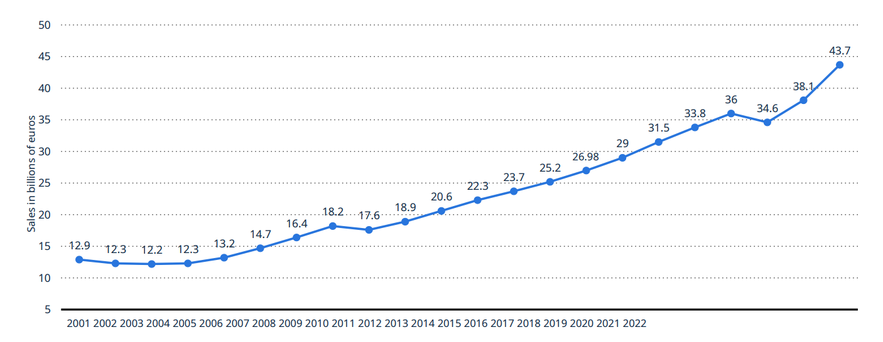

Figure 7: Sales of the management consulting industry in Germany (BDU, 2023).

According to Lünendonk's (2023) chart in Figure 8, Roland Berger dominated Germany's management consulting market in 2022, generating 870 million euros. The second-ranked firm trailed with 534.9 million euros, approximately 335 million euros less than Roland Berger. Q_Perior AG came in third with 286 million euros, followed by Porsche Consulting Group and Horváth AG (Horváth & Partners Group), which reported revenues of 271 million and 270 million euros, respectively.

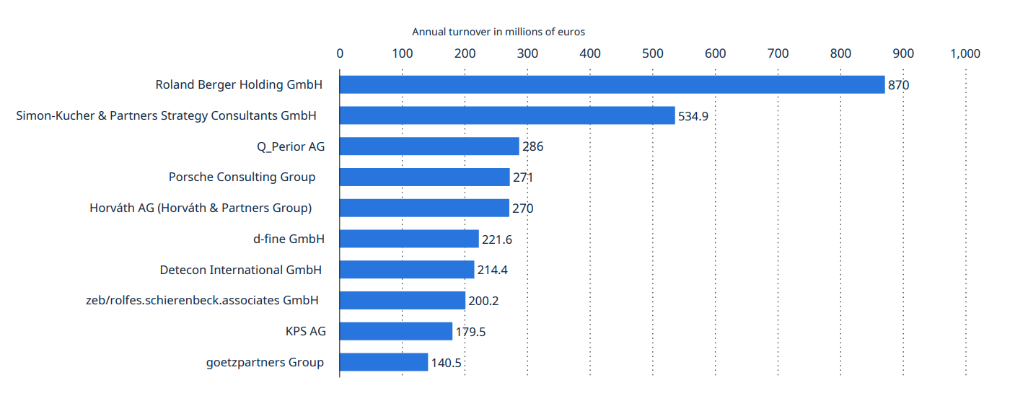

Figure 8: Leading management consultancies in Germany by sales (Lünendonk, 2023).

Based on the profitability metrics for the management consulting industry in Germany data analyzed, Germany's management consulting industry is not only profitable but also expanding, with sales surging to 43.7 billion euros in 2022 and the number of firms doubling over a decade. For LMDT Consulting Ltd, this data points to a dynamic and prosperous market with significant potential for revenue generation if they expand to Germany.

### 3.1.2 Market Growth Rate in the Service Sector in Germany

According to the Hithorizons (2024) chart in Figure (9), Germany's Services sector is the largest, with 1,484,935 registered companies and 69.3% of GDP, highlighting the country's service-oriented economy. The sector is followed by Finance, Insurance, and Real Estate (499,075 companies) and Construction (174,327 companies, 6% of GDP). The Production Industry, excluding construction, is the second largest GDP contributor at 23.5%, whereas Agriculture, Forestry, and Fisheries account for only 1.2% of total production.

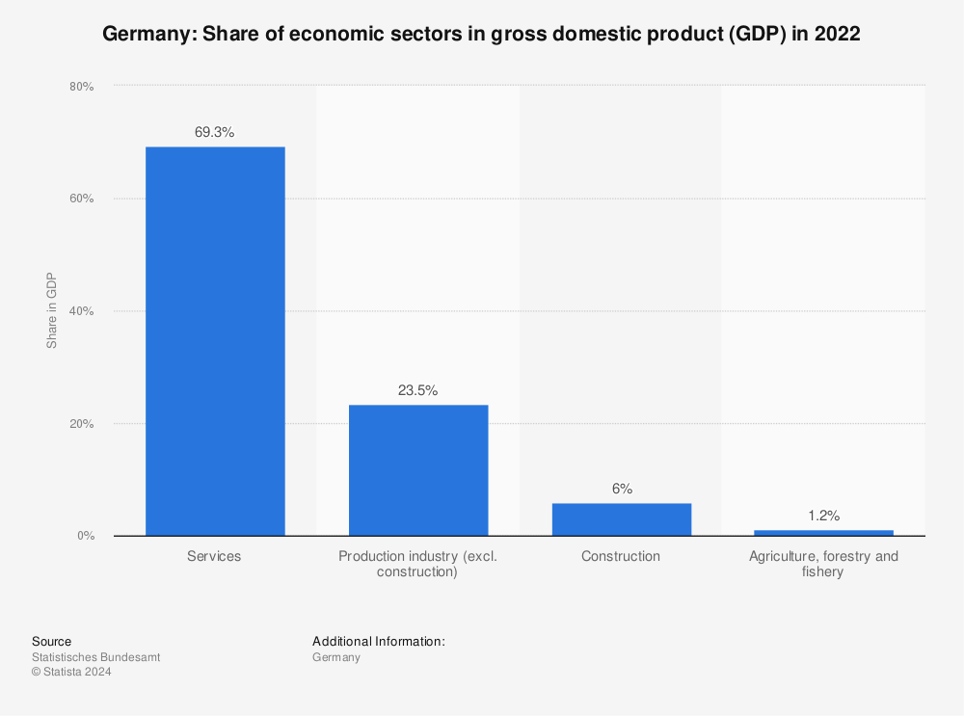

Figure 9: Germany: Share of economic sectors in GDP(Statistisches Bundesamt, 2023a).

Figure (10) shows that business confidence in the service sector peaked in 2021 and 2022, with indices of 35.97 and 34.23, reflecting a strong and optimistic outlook (McEvoy, 2024). Despite changes over the last 15 years, the overall trend indicates that company confidence is improving, most likely due to economic development and favourable market circumstances.

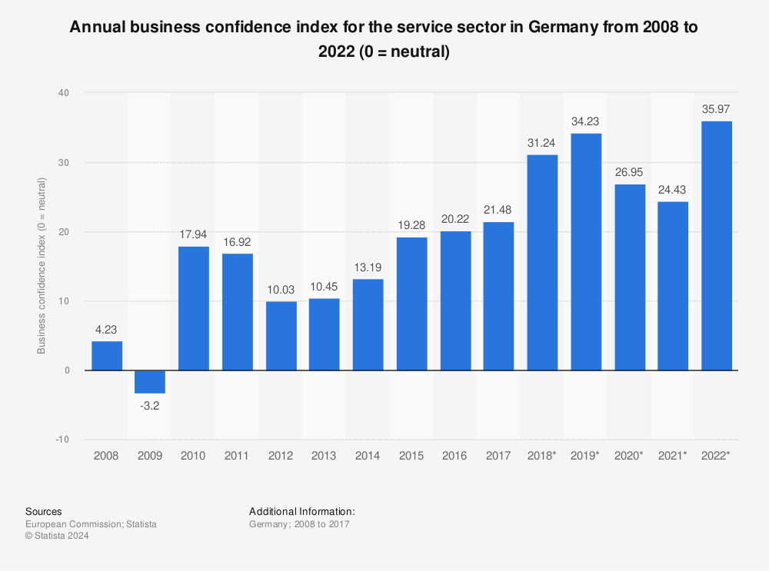

Figure 10: Annual business confidence index (McEvoy, 2024).

The graph (Figure 11) depicts the indexed turnover in Germany's service sector from 2008 to approximately 2022. This shows a consistent upward trajectory, adjusted for seasonality and working days (Destatis, 2023).

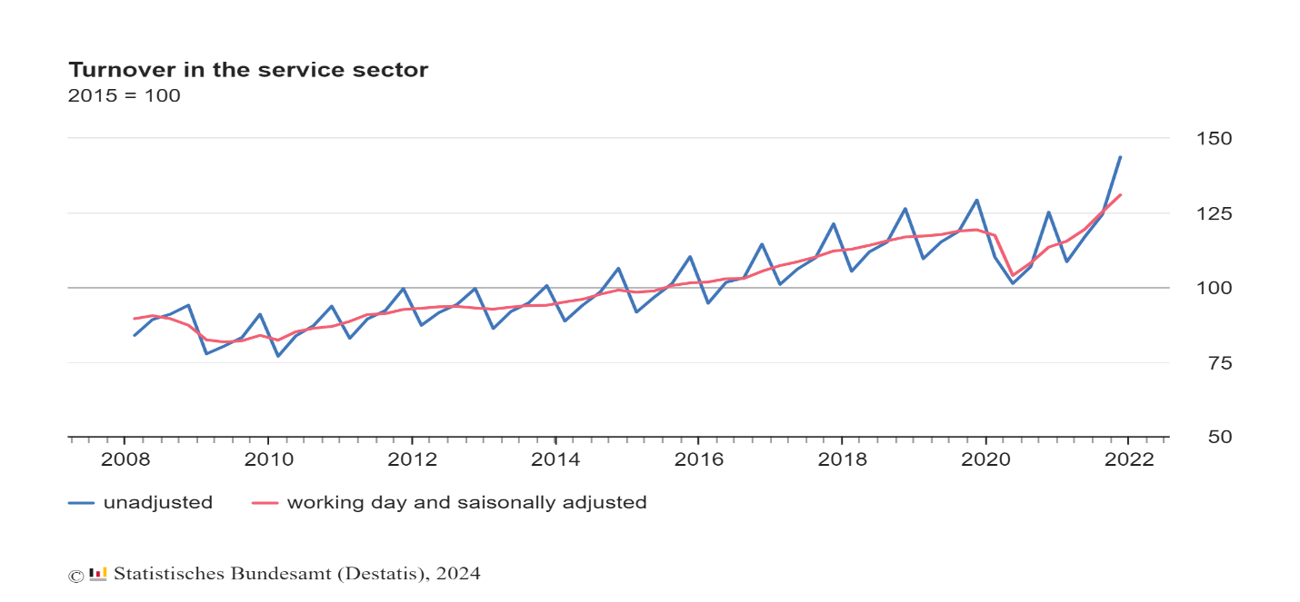Figure 11: Turnover in the Service sector (Destatis, 2023)

This trend, coupled with the significant GDP contribution and high business confidence post-2020, indicates a resilient and growing market, presenting an excellent opportunity for LMDT Consulting Ltd to establish or expand its services in Germany.

### 3.1.3 Market size of the consulting sector in Germany

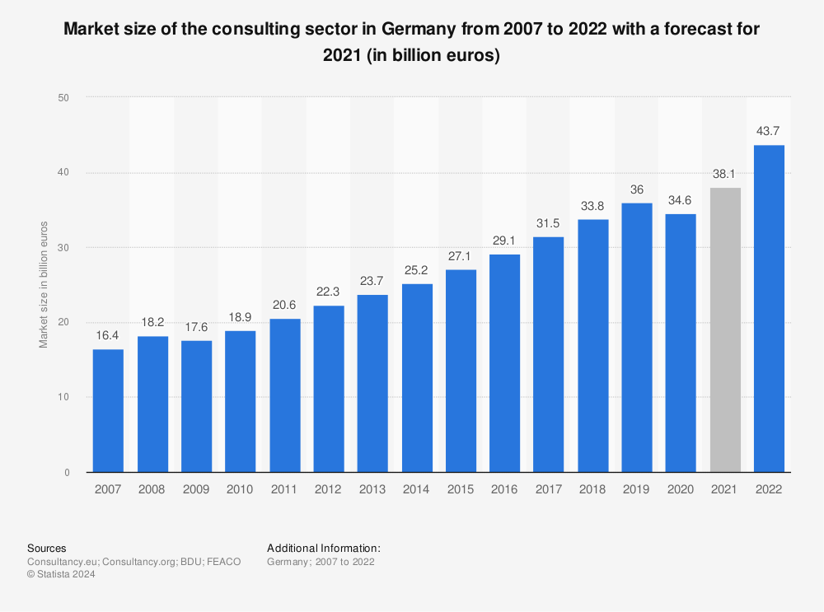

Figure 12: Market size of the consulting sector in Germany (Consultancy.eu, 2023).

According to Figure (12), the consulting industry's market size has steadily increased over time, with a significant decline in 2020 indicating the impact of the COVID-19 pandemic. The market is expected to rebound strongly in 2021, with a projected value of 38.1 billion euros, the highest year-on-year increase since 2020. Since 2007, the industry has more than doubled, rising from 16.4 billion euros to the projected 2021 figures.

Jörg Hossenfelder, Managing Director of Lünendonk, emphasised the remarkable growth in 2022, citing a high demand for consulting services the previous year (Thaler-Lang, 2023). According to Consulting Point's 2022 report, recruitment initiatives resulted in a 15.5% workforce growth rate for the top 20 German consulting firms and an 18.9% increase for international consultants.

For LMDT Consulting Ltd, Germany's robust growth and expanding pool of potential clients present a promising market, justifying a strategic entry into this region to capitalise on its burgeoning consulting needs, providing a favourable environment for growth and profitability.

### 3.1.4 Client Demand for HR Services in Germany

Chugunova and Danilov (2023) conducted an online survey of executives from various German organisations to investigate the demand for HR services.

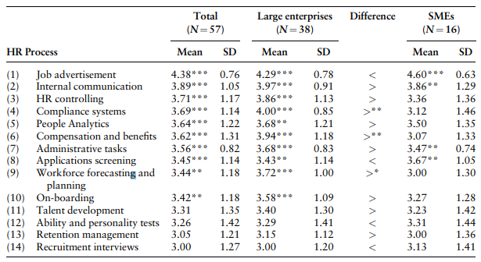

Figure 13: The average degree of digitalisation of HR processes (Chugunova and Danilov, 2023).

Figure (13) shows the adoption of digital HR processes across various services. Job advertisements are popular, with SMEs showing slightly higher usage (mean SMEs: 4.60) than large corporations. Internal communication and compliance systems are critical in larger organisations, scoring 3.97 and 4.00, respectively. HR control is also widely used in larger enterprises (mean large: 3.86).

People analytics and administrative tasks are moderately demanded across both business sizes, with larger companies showing slightly more interest (mean large: 3.68 for both). Compensation and benefits also rank high, particularly in larger businesses (mean: 3.94). Application screening, while moderate overall, is more common in SMEs (mean SMEs: 3.67).

Workforce forecasting and planning are in higher demand in larger enterprises (mean large: 3.72), as are onboarding processes (mean large: 3.58). Talent development, ability, and personality tests are in moderate demand, with SMEs slightly favouring the latter (mean SMEs: 3.23).

The Chugunova and Danilov survey shows that German companies are increasingly using digital tools for HR, with large firms leading the adoption. There's a high demand for services like digital job ads, people analytics and employee assessments and moderate demand for compensation and benefit, HR control, and workforce forecast and planning. For LMDT Consulting Ltd, expanding to Germany could mean a significant opportunity to provide these in-demand digital HR services.

## 3.2 Evaluation of the United Arab Emirate

### 3.2.1 Profitability of the Service in the United Arab Emirate

Figure (14) depicts the revenue of "professional, scientific, and technical activities" in the United Arab Emirates (UAE) between 2012 and 2024.

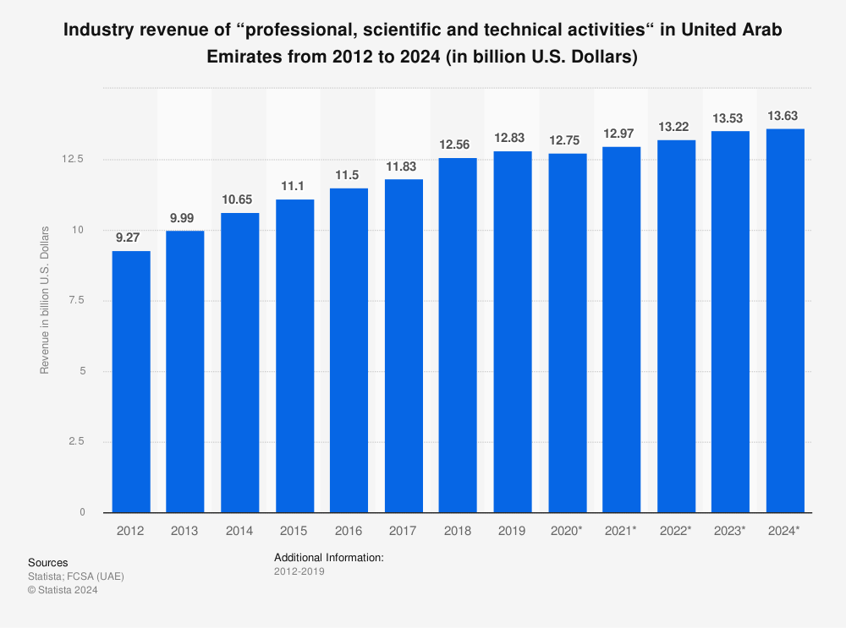

Figure 14: Industry revenue of “professional, scientific and technical activities“ in the United Arab Emirates from 2012 to 2024 (FCSA (UAE), 2020).

From 2012 to 2019, the UAE's professional, scientific, and technical activities sector experienced consistent revenue growth, with only a slight dip in 2015. There are projections for further growth to $13.63 billion by 2024, representing a $4.36 billion increase in 12 years. This consistent growth indicates a high demand for these services. For LMDT Consulting Ltd, the UAE's robust and expanding market presents a compelling opportunity for expansion, which aligns well with their service offerings and has the potential for profitable ventures.

### 3.2.2 Market Growth Rate in the Service Sector in the United Arab Emirate

The service sector's contribution to GDP is steadily increasing. According to Figure (15), it contributed 47.38% in 2014, 56.7% in 2017, and a slight increase to 56.86% in 2020. Starting at 42.8% in 2012, it peaked at 58.22% in 2016, then moderated to 47.72% in 2022. This upward trend demonstrates the growing importance of the service sector in the UAE's economic landscape.

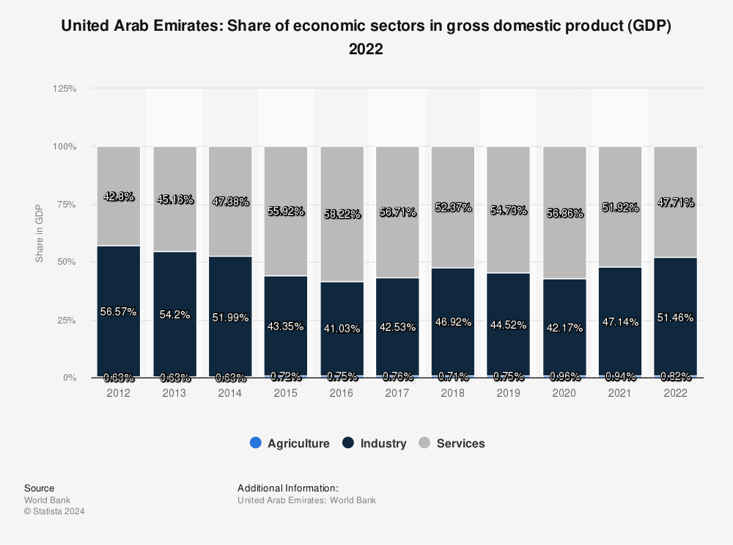

Figure 15: United Arab Emirates: Share of economic sectors in gross domestic product (GDP) 2022.

According to the sectoral analysis of the UAE's top service imports, as shown in Figure (16), the Other Commercial Service sector increased by 13% from 35.75 billion USD in 2020 to 40.49 billion USD in 2021.

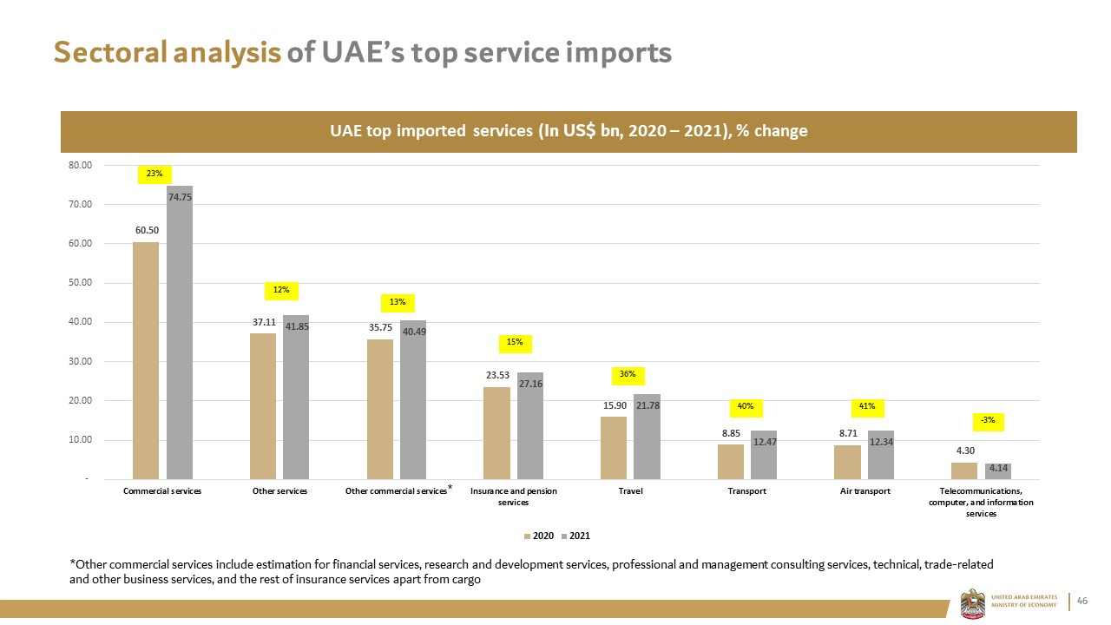

Figure 16: Sectoral analysis of UAE’s top service imports (UAE Embassy, 2024).

The 13% increase in "Other Commercial Services" indicates a significant increase in demand for these services in the UAE.

The UAE's service sector has expanded dramatically, indicating a shift towards a service-oriented economy. This growth presents an excellent opportunity for LMDT Consulting Ltd to enter a market with increasing demand for their expertise in professional and management consulting, indicating the possibility of profitable expansion.

### 3.2.3 The market size of the Consulting Sector in the United Arab Emirates

According to Loyica (2024), the consulting industry in the UAE is massive. Many consulting firms collaborate with the public sector, assisting governments in diversifying their economies and reducing reliance on oil revenues.

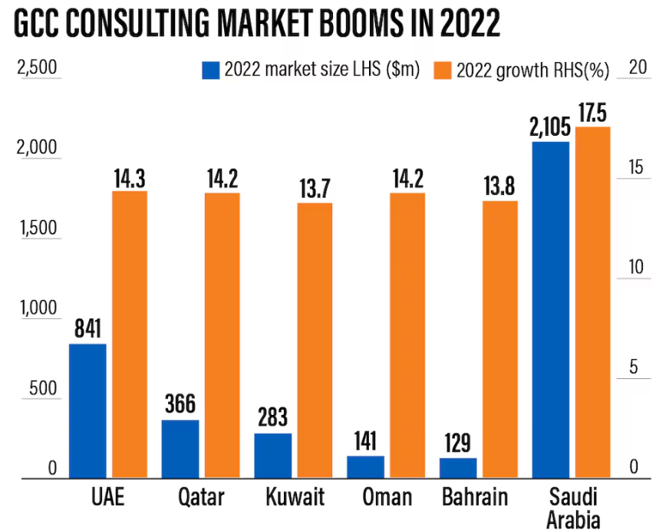

Figure 17: GCC Consulting Market (Nagraj, 2022).

Figure (17) shows a chart comparing the consulting sector's market size and growth rate in various Gulf Cooperation Council (GCC) countries for the year 2022. The UAE has the second largest consulting market in the GCC region (after Saudi Arabia), growing by 14.3% to US$841 million in 2022.

This places the UAE as the second-largest consulting market in the GCC, indicating a strong and expanding demand for consulting services, providing a lucrative opportunity for LMDT Consulting Ltd to enter and capitalise on this growing market.

### 3.2.4 Client Demand for HR Services in the United Arab Emirates

Workforce planning and management is a top five workforce priority common to respondents across the three MENA countries surveyed, Egypt, KSA and UAE (CIPD, 2023).

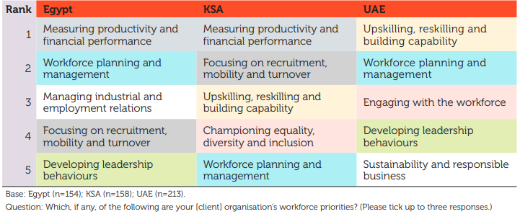

Figure 18: The top five workforce priorities in MENA country organisations (CIPD, 2023).

A survey of 213 respondents in the UAE, as shown in Figure (18) reveals that;

* Upskilling, reskilling, and capability development are the top priorities.
* The second highest priority is strategic human resource planning for workforce management.
* The third priority is to improve employee interaction and leadership development.

According to the CIPD (2023) chart in Figure (19), with a focus on the UAE, "Building specialist HR expertise," is the primary focus of 22% of UAE respondents. This demonstrates the need for greater expertise in the HR function. The UAE's third priority, accounting for 22% of its efforts, is to improve its people analytics capabilities. This highlights the growing importance of making HR decisions based on data-driven insights.

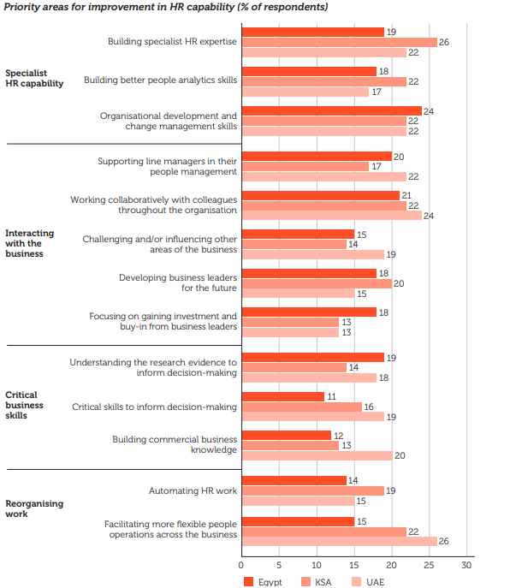

Figure 19: Priority areas for improvement in HR capability (% of respondents) (CIPD, 2023).

This analysis underscores a significant shift towards enhancing HR capabilities and digitalization, presenting a promising opportunity for LMDT Consulting Ltd to meet these evolving needs with their specialized services in workforce management and HR technology integration.

## 3.3 The Best Destination for Expansion and Recommendation

After a thorough examination of data from Germany and the UAE, it is clear that Germany is the best location for LMDT Consulting Ltd to expand its operations. Germany has a robust management consulting market, with revenues expected to reach €43.7 billion by 2022, indicating strong demand for consulting services. The market benefits from a diverse industrial base, ranging from automotive to IT, which creates numerous opportunities for services such as strategic workforce planning and talent acquisition for LMDT.

Furthermore, the growing number of consulting firms, as well as a shift towards strategic and value-enhancing HR functions, demonstrate the demand for HR services in Germany. The country's emphasis on digitization and Industry 4.0 highlights the importance of integrating HR technology, which can help businesses increase efficiency and adapt to new technological landscapes. Furthermore, Germany's service sector, which employs a large proportion of the workforce and contributes significantly to GDP, complements LMDT's expertise in HR-related digital tools and platforms, particularly in compliance and strategic workforce management. This synergy makes Germany an ideal market for LMDT Consulting Ltd's expansion and service offerings.

# 4. Market Entry Strategy

## 4.1 Mergers and Acquisitions Entry Strategy in Germany

The Mergers and Acquisitions market in Germany is currently witnessing a substantial upward trend, drawing the attention of both domestic and international investors (Statista, 2024). Statista (2024) reports that the average transaction value in the Mergers and Acquisitions market in Germany is projected to be €97.85m in 2024. The graph in Figure (20) illustrates the patterns of mergers and acquisitions (M&A) in Germany from 1991 to the projected data for 2024.

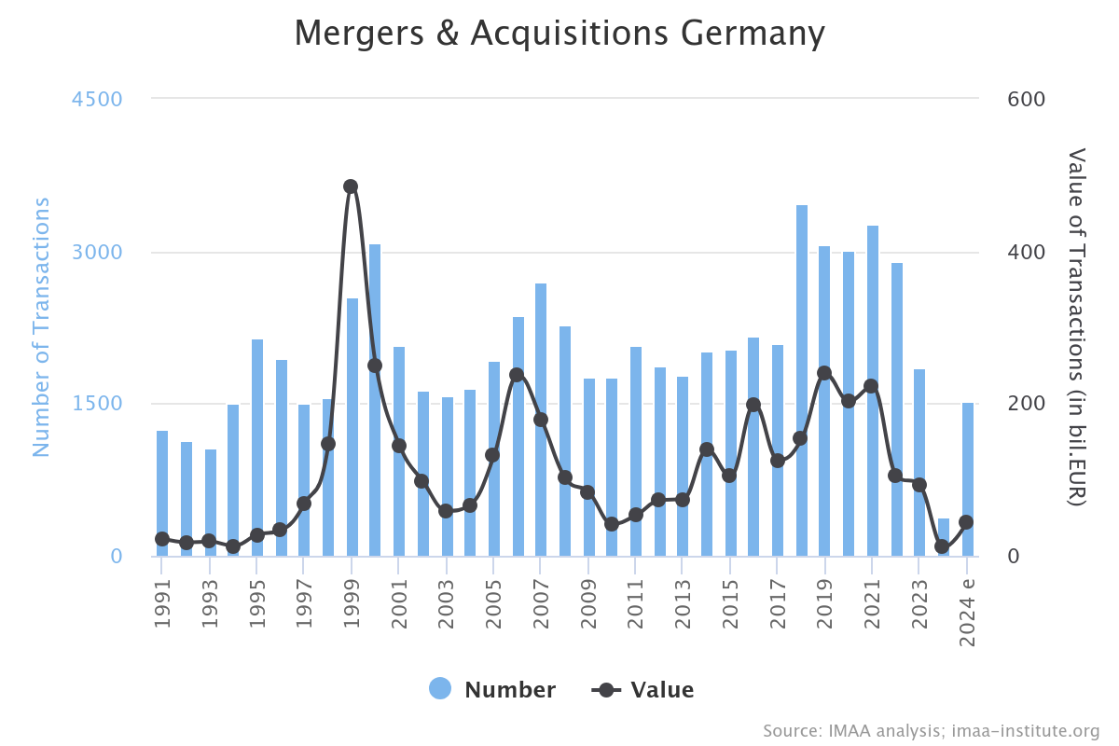

Figure 20: M&A Germany by Numbers & Value by Years (IMAA, 2024).

This graph shows the number and value of mergers and acquisitions (M&A) in Germany from 1991 to 2024. It shows a peak in the number of transactions around 2000, followed by a significant decline and subsequent shift over the next few years. The value of transactions also varies, with notable peaks in the early 2000s and mid-2010s. By 2024, both the number and value of transactions show signs of stabilizing after a noticeable dip in 2020.

Germany's positioning as a hub for both domestic and international investors underscores its strategic significance and the vibrant business activities occurring there, making it a good environment for LMDT to integrate and grow. The high activity in the number and value of transactions over the years also shows how much companies consider this method, making it a good entry strategy for LMDT Consulting Ltd.

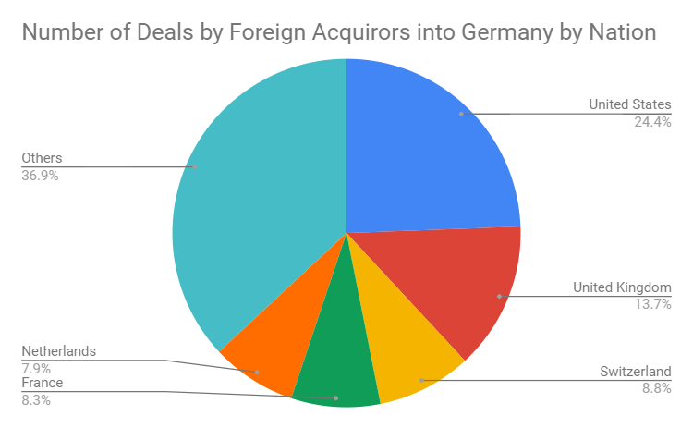

Figure 21: Number of Deals by Foreign Acquirors into Germany by Nation (Institute for Mergers, Acquisitions and Alliances (IMAA), 2024).

The pie chart in Figure (21) shows the distribution of mergers and acquisitions deals in Germany by foreign acquirers, broken down by country. The United States leads with 24.4% of the transactions, followed by the United Kingdom (13.7%), Switzerland (8.8%), France (8.3%), and the Netherlands (7.9%). All other countries together account for 36.9% of the transactions. This demonstrates a substantial international interest in the German market, with the United States and the United Kingdom being the primary foreign investors and shows a welcoming environment for foreign enterprises which aligns with LMDT's goals to expand its global footprint.

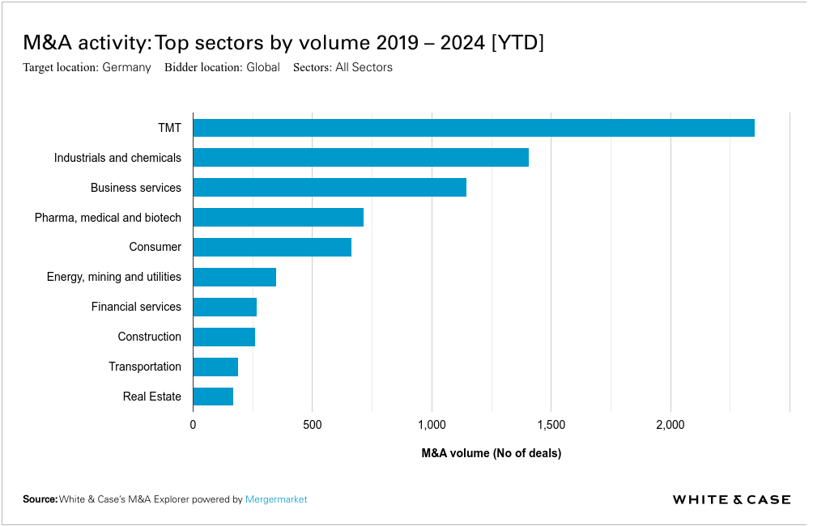

Figure 22: Germany M&A activity by value 2019 – 2024 [YTD] (Whitecase, 2024).

The bar chart in Figure 22 shows Mergers and Acquisitions (M&A) activity by sector from 2019 to YTD 2024. The Technology, Media, and Telecommunications (TMT) sector leads with 2354 deals, followed by Industrials and Chemicals with 1408 transactions, and Business Services with 1145 transactions, indicating a robust market. The substantial M&A activity facilitates LMDT's market entry strategy in Germany through acquisitions, granting immediate access to established networks, local talent, and a customer base, thereby accelerating its business objectives.

## 4.2 The top HR consulting firms in Germany for potential merger and acquisition opportunities by LMDT Consulting Ltd

According to the analysis in Section 3.1.4 of the Client Demand for HR Services in Germany, there is a high demand for services such as Performance Management, Training and Development, Compliance, Legal, Compensation and Benefits the use of data analytics for informed HR decision-making. In Table 1 are top HR consulting firms in Germany that LMDT Consulting Ltd can merge with or acquire (full top 24 HR consulting firms in the Appendix).

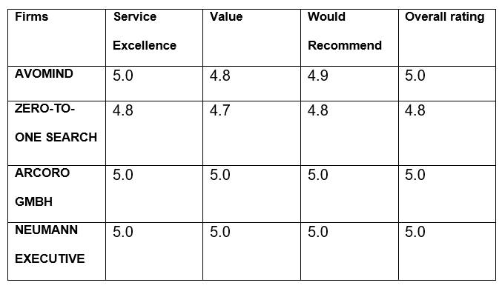

Table 1: Top 4 HR consulting firms in Germany

# 5. Implementation of Data Analysis

## 5.1 Implementation of Data Analysis for LMDT Consulting Ltd

The data analysis implementation plan shown in Figure (22) is a complete approach to using data for strategic advantage, which is vital to LMDT Consulting Ltd as the company expands its operations to Germany. This will be done within 12 weeks.



Figure 22: Data Analysis Implementation Plan Chart

Here's what this means to the LMDT Consulting Ltd:

**Data Integration and Warehousing**

This is a process of combining data from diverse business systems to generate a unified, single view, often known as a single view of the truth. This aggregated data is typically stored in a central location known as a data warehouse in the case of LMDT Consulting Ltd, the central location will be in Germany, as according to Baker McKenzie (2023), companies are generally required to keep their books and records (i.e., accounting data, client data, customer data) in the German territory. By integrating diverse data types (market performance, sales, and customer feedback) into a single data warehouse like Snowflake, Microsoft Azure, Panoply, etc., LMDT will gain a unified view of its operations and market dynamics.

**Analytics Tool Setup**

Implementing business intelligence and analytics tools such as Tableau or Power BI allows LMDT to effectively process and analyze data. This capability will enable LMDT Consulting Ltd to derive actionable insights that can inform strategic decisions and optimize business operations.

**Development of Analytical Models**

Creating models to analyze sales trends and market entry equips LMDT with predictive capabilities. In the case of LMDT Consulting Ltd, the company can use analytical model tools such as ER/Studio, SQL Database Modeler, ERBuilder Data Modeler, etc., (Indeed, 2022). This can improve marketing strategies and anticipate market shifts, giving LMDT a competitive edge in the consulting industry.

**KPI and Dashboard Development**

Dashboards provide an at-a-glance view of the company’s health and progress, making it easier to track and achieve business objectives (NetSuite.com, 2022). Human Resources key performance indicators (HR KPIs) are HR metrics that are used to see how HR is contributing to the rest of the organization (Van Vulpen, 2019). According to Burns (2024), here are the **top 10 KPIs** a consulting firm should track with their dashboard.

* Utilization Rate
* Effective Bill Rate
* Net Revenue per Full-Time Employee
* Client Satisfaction Score
* Client Retention Rate
* Sales Conversion Rate
* Revenue Growth
* Profit Margin
* Aged Accounts Receivable
* Project / Engagement Profit

Figure (23) below is a sample of the dashboard used by HR consulting firms. This Dashboard was created by MRC Productivity, a platform trusted by over 1,500 companies worldwide for the creation of KPI Dashboard Consulting Services (MRC Productivity, 2024). Using this Dashboard, LMDT consulting can now take advantage of the already processed and structured data, visualise the KPIs, and input it into the MRC Productivity software or other visualization/reporting tools such as Excel, PowerBi or Tableau for analysis and generate data-driven insights.

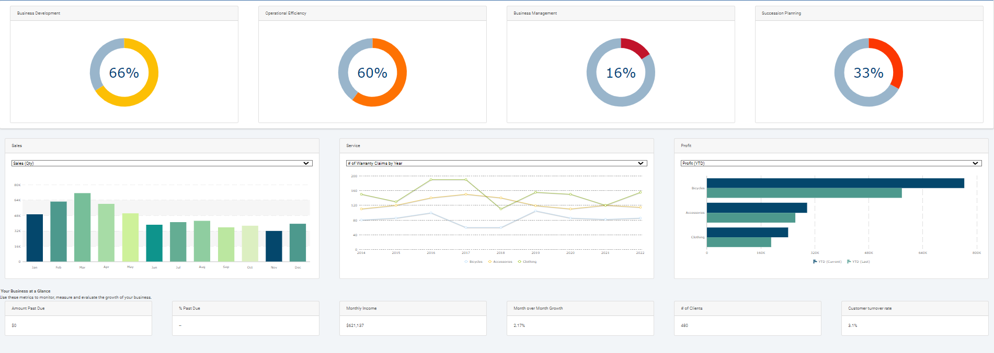

Figure 23: KPI Dashboard Consulting Services (MRC Productivity, 2024).

**Regular Reporting System**

In this stage, LMDT will be generating regular insightful reports to ensure that all levels of the organization are informed and aligned with the company's strategic direction. This regular dissemination of findings supports a culture of data-driven decision-making within LMDT Consulting Ltd.

**Feedback Loop for Strategy Adjustment**

In this stage, integrating a feedback loop where analytical insights are used to refine and adjust business strategies ensures that LMDT remains agile and responsive to market conditions. LMDT Consulting Ltd can use tools such as Slack or Microsoft Teams to facilitate the quick sharing of insights and foster a dynamic strategic planning process.

## 5.2 Data Analysis Role in Strategic Decision-Making

**Market Entry Strategy Adjustments**: LMDT Consulting Ltd can use data analysis on market trends and client preferences to refine market entry strategies. The company can do this by shifting focus to more lucrative market sectors or adjusting service offerings based on performance data.

**Product and Service Development**: LMDT Consulting Ltd can leverage client feedback and performance data to innovate or improve services. For example, if data shows high demand for specific HR consulting services like talent acquisition and recruitment, strategic workforce planning, employee development and training or HR technology integration, LMDT could focus on it.

**Performance Benchmarking**: Data analysis can help LMDT Consulting Ltd to regularly compare performance against industry standards and competitors. This can identify areas of strength and weakness, guiding strategic decisions on where to allocate resources.

**Risk Management**: Data analytics will enable LMDT Consulting Ltd to anticipate potential market risks and downturns. Using data analytics to predict potential market risks and downturns, LMDT Consulting Ltd can prepare and adjust its strategies, potentially mitigating risks before they impact the business.

# 6. Conclusion and Recommendation

This consultancy report evaluated LMDT Consulting Ltd's potential expansion into the UAE and Germany. Using market analysis tools such as PESTLE, Porter's Five Forces and data analytics, the report shows that Germany offers a stable environment with a high demand for HR services, a robust consulting market and a robust technological infrastructure. The report also shows that the ideal market entry strategy is mergers and acquisitions.

LMDT Consulting Ltd should leverage data analytics to refine market entry strategies continuously and enhance offerings in HR technology, particularly in AI and predictive analytics for talent management, digital HR Offerings, and workforce planning. The company should navigate regulatory environments proactively, focusing on compliance and risk management to align with local policies in Germany. LMDT Consulting Ltd will also be able to monitor/track activities and progress within the organisation and market environment making use of the data analysis implementation plan recommended.

Implementing these strategies will position LMDT Consulting Ltd advantageously in the global consulting industry, promoting long-term growth and competitive advantage in these dynamic markets.

# References

Accenture (2015). *Industrial Internet of Things Will Boost Economic Growth, but Greater Government and Business Action Needed to Fulfill its Potential, Finds Accenture*. [online] newsroom.accenture.com. Available at: https://newsroom.accenture.com/news/2015/industrial-internet-of-things-will-boost-economic-growth-but-greater-government-and-business-action-needed-to-fulfill-its-potential-finds-accenture [Accessed 11 Apr. 2024].

Akrivia (2023). *How HR Transformation is Shaping UAE’s Workforce | Akrivia HCM*. [online] Akrivia HCM Blog. Available at: <https://akriviahcm.com/blog/shaping-uaes-workforce-through-hr-transformation> [Accessed 21 Mar. 2024].

Ali, W. (2023). *Exploring the Best UAE Free Zones for Tech Startup Success l Al Sharqi*. [online] Al Sharqi. Available at: <https://www.alsharqi.co/blog/exploring-the-best-free-zones-in-the-uae-for-tech-startups/> [Accessed 21 Mar. 2024].

Al Helou, E. (2023). *Green Workforce boom: UAE Witnesses 26 Percent Surge in Environmental Experts*. [online] Economy Middle East. Available at: https://economymiddleeast.com/news/green-workforce-boom-uae-witnesses-26-percent-sustainability-in-environmental-experts/ [Accessed 7 Apr. 2024].

Anastasiu, L., Gavriş, O. and Maier, D. (2020). Is Human Capital Ready for Change? a Strategic Approach Adapting Porter’s Five Forces to Human Resources. *Sustainability*, [online] 12(6), pp.1–20. Available at: <https://www.mdpi.com/2071-1050/12/6/2300>.

Alonso, T. (2023). *Porter’s Five Forces (2024): the Definitive Overview (+ Examples)*. [online] Cascade. Available at: <https://www.cascade.app/blog/porters-5-forces>.

AppliedAI Institute for Europe (2023). *German AI Startup Landscape 2023*. [online] www.appliedai-institute.de. Available at: https://www.appliedai-institute.de/en/hub/2023-ai-german-startup-landscape [Accessed 16 Mar. 2024].

ARAB NEWS (2024). *UAE’s GDP to grow over 5% in 2024: S&P Global*. [online] Arab News. Available at: https://www.arabnews.com/node/2442436/business-economy [Accessed 10 Mar. 2024].

Baker McKenzie (2022). *Number of M&A transactions Germany 2015-2022*. [online] Statista. Available at: https://www.statista.com/statistics/797121/merger-and-acquisition-transaction-numbers-germany/ [Accessed 23 Apr. 2024].

Baker McKenzie (2023). *Data Localization/Residency | Germany | Global Data Privacy and Cybersecurity Handbook | Baker McKenzie Resource Hub*. [online] resourcehub.bakermckenzie.com. Available at: https://resourcehub.bakermckenzie.com/en/resources/global-data-privacy-and-cybersecurity-handbook/emea/germany/topics/data-localizationresidency#:~:text=Companies%20are%20generally%20required%20to [Accessed 30 Apr. 2024].

Bandara, S. (2023). *UAE: the next Global Hub of Human Capital Development?* [online] www.linkedin.com. Available at: <https://www.linkedin.com/pulse/uae-next-global-hub-human-capital-development-saumya-bandara-x1zuc/>.

BDO (2023). *Minimum Wage and Mini-Job Threshold Will Rise on January 1, 2024 - BDO*. [online] www.bdo.de. Available at: https://www.bdo.de/en-gb/insights/updates/tax-legal/minimum-wage-and-mini-job-threshold [Accessed 11 Apr. 2024].

BDU (2022). *Unternehmensberatungen in Deutschland bis 2021*. [online] Statista. Available at: https://de.statista.com/statistik/daten/studie/261256/umfrage/anzahl-der-beratungsfirmen-in-deutschland/ [Accessed 17 Apr. 2024].

BDU (2023). *Unternehmensberatungsbranche - Umsatz bis 2019*. [online] Statista. Available at: https://de.statista.com/statistik/daten/studie/7120/umfrage/umsatz-der-unternehmensberatungsbranche-in-deutschland/ [Accessed 17 Apr. 2024].

Behrens, B. (2022). *Shaping Sustainability with Green Human Resources management: a New and Vital Field of Action in Environmental Management*. [online] Eipa. Available at: https://www.eipa.eu/blog/shaping-sustainability-with-green-human-resources-management-a-new-and-vital-field-of-action-in-environmental-management/ [Accessed 9 Apr. 2024].

Benny, J. (2023). *UAE highest ranked Arab country on UN Frontier Technology Readiness index*. [online] The National. Available at: https://www.thenationalnews.com/business/technology/2023/05/03/uae-highest-ranked-arab-country-on-un-frontier-technology-readiness-index/ [Accessed 10 Mar. 2024].

Bhat, D. (2022). *Why Sustainability Must Be a Top Priority for UAE Organisations*. [online] Gulf Business. Available at: https://gulfbusiness.com/why-sustainability-must-be-a-top-priority-for-uae-organisations/ [Accessed 7 Apr. 2024].

Bitkom. (2023). Number of IT positions in Germany 2023 [Graph]. In Statista. Retrieved March 21, 2024, from https://www.statista.com/statistics/1379250/it-positions-germany/

Braeckeler-Kogel, V. and Rehner, M.C. (2024). *Germany: Changes to the German Immigration Act for Skilled Workers have come into Force*. [online] L&E Global. Available at: https://leglobal.law/2024/03/22/germany-changes-to-the-german-immigration-act-for-skilled-workers-have-come-into-force/#:~:text=The%20second%20stage%20of%20the [Accessed 11 Apr. 2024].

Brewster, C., HoltLarsen, H. and Trompenaars, F. (1992). Human resource management in Europe: evidence from ten countries. *The International Journal of Human Resource Management*, 3(3), pp.409–434. doi:https://doi.org/10.1080/09585199200000157.

Bruin, L. de (2016). *PESTEL Analysis (PEST Analysis) EXPLAINED with EXAMPLES | B2U*. [online] B2U - Business-to-you.com. Available at: https://www.business-to-you.com/scanning-the-environment-pestel-analysis/#google_vignette [Accessed 25 Mar. 2024].

Bryzek, S. (2023). *CNBC: Refugees could help Germany’s labor market, but Ukraine’s skilled workers are needed at home*. [online] EWL Group. Available at: https://ewl.com.pl/en/cnbc-refugees-could-help-germanys-labor-market-but-ukraines-skilled-workers-are-needed-at-home/ [Accessed 3 May 2024].

BT NEWS DESK (2022). *48% UAE IT decision-makers view shortage of IT skills as a threat to their business*. [online] Bizness Transform. Available at: https://www.biznesstransform.com/48-uae-it-decision-makers-view-shortage-of-it-skills-as-a-threat-to-their-business/ [Accessed 14 Mar. 2024].

BTI Transformation Index (2022). *BTI 2022: United Arab Emirates*. [online] BTI 2022. Available at: https://bti-project.org/en/reports/country-dashboard/ARE [Accessed 10 Mar. 2024].

Bundesagentur für Arbeit (2023). *Unemployment rate in Germany 2020*. [online] Statista. Available at: https://www.statista.com/statistics/227005/unemployment-rate-in-germany/.

Bundesagentur für Arbeit (2024). *Startseite - statistik.arbeitsagentur.de*. [online] Arbeitsagentur.de. Available at: https://statistik.arbeitsagentur.de/ [Accessed 13 Mar. 2024].

Burns, S. (2024). *The Top 10 KPIs Consulting Firms Should Track*. [online] blog.bqe.com. Available at: https://blog.bqe.com/the-top-10-kpis-consulting-firms-should-track [Accessed 30 Apr. 2024].

Castillo, A. and Poushter, J. (2019). *Americans, Germans Disagree on Their Relationship*. [online] Pew Research Center’s Global Attitudes Project. Available at: <https://www.pewresearch.org/global/2019/03/04/americans-and-germans-disagree-on-the-state-of-bilateral-relations-but-largely-align-on-key-international-issues/>.

Cave, D. (2022). *The top 10 German HR tech startups for 2023*. [online] UNLEASH World. Available at: <https://www.unleash.ai/unleashworld/hr-tech/the-top-10-german-hr-tech-startups-for-2023/> [Accessed 3 Apr. 2024].

Charlesworth (2022). *What are the skills needed for applied research? | CW Authors*. [online] Cwauthors.com. Available at: https://www.cwauthors.com/article/skills-needed-for-applied-research [Accessed 29 Apr. 2024].

Chugunova, M. and Danilov, A. (2023). Use of Digital Technologies for HR Management in Germany: Survey Evidence. *CESifo Economic Studies*, [online] Volume 69. doi:https://doi.org/10.1093/cesifo/ifad005.

CIPD (2023). *People Profession 2023 Middle East and North Africa survey report*. [online] Available at: https://www.cipd.org/globalassets/media/knowledge/knowledge-hub/reports/2023-pdfs/2023-people-profession-report-middle-east-north-africa-2.pdf [Accessed 20 Apr. 2024].

Clasen, A. (2024). *German government provides additional funding for tech start-ups*. [online] www.euractiv.com. Available at: https://www.euractiv.com/section/digital/news/german-government-provides-additional-funding-for-tech-start-ups/ [Accessed 16 Mar. 2024].

Consultancy.eu (2023). *Consulting sector market size Germany 2022*. [online] Statista. Available at: https://www.statista.com/statistics/1227413/consulting-sector-market-size-germany/#:~:text=The%20market%20size%20of%20the [Accessed 20 Apr. 2024].

Consulting Point (2022). *Lünendonk list 2022 management consulting: German consulting market is recovering*. [online] Consulting Point. Available at: https://www.consultingpoint.com/news/2022/8/5/lnendonk-list-2022-management-consulting-german-consulting-market-is-recovering [Accessed 11 Apr. 2024].

Cooper Fitch (2024). *United Arab Emirates Salary Guide 2024*. [online] Cooper Fitch. Available at: https://cooperfitch.ae/salary-guides/united-arab-emirates-salary-guide-2024/ [Accessed 6 Apr. 2024].

Davies, K. (2023). *Apprenticeships: Supply and Demand in Germany 2020*. [online] Statista. Available at: https://www.statista.com/statistics/1182216/apprenticeships-applicants-number-germany/ [Accessed 8 Apr. 2024].

Davies, K. (2024). *IT positions Germany 2023*. [online] Statista. Available at: https://www.statista.com/statistics/1379250/it-positions-germany/#:~:text=Number%20of%20IT%20positions%20Germany%202023&text=In%202023%2C%20there%20were%20around [Accessed 15 Mar. 2024].

Debruin, L. (2016). *Porter’s Five Forces*. [online] B2U - Business-to-you. Available at: <https://www.business-to-you.com/porters-five-forces/>.

Deloitte (2022). *Doing business guide Understanding the United Arab Emirates’ tax position*. [online] Available at: https://www2.deloitte.com/content/dam/Deloitte/xe/Documents/tax/doing-business-guide-uae-2022.pdf [Accessed 12 Mar. 2024].

DeStatis (2022). *Germany with fourth lowest unemployment rate in the EU-27 - Statistisches Bundesamt*. [online] www.destatis.de. Available at: https://www.destatis.de/Europa/EN/Topic/Population-Labour-Social-Issues/Labour-market/EULabourMarketCrisis.html [Accessed 13 Mar. 2024].

DeStatis (2023). *Current population of Germany*. [online] Federal Statistical Office. Available at: https://www.destatis.de/EN/Themes/Society-Environment/Population/Current-Population/_node.html [Accessed 14 Mar. 2024].

Destatis (2022). *Consumer price index*. [online] Federal Statistical Office. Available at: https://www.destatis.de/EN/Themes/Economy/Prices/Consumer-Price-Index/_node.html [Accessed 14 Mar. 2024].

Destatis (2023). *Services*. [online] Federal Statistical Office. Available at: https://www.destatis.de/EN/Themes/Economic-Sectors-Enterprises/Services/_node.html#265910 [Accessed 11 Apr. 2024].

DiRomualdo, A., El-Khoury, D. and Girimonte, F. (2018). HR in the digital age: how digital technology will change HR’s organization structure, processes and roles. *Strategic HR Review*, 17(5), pp.234–242. doi:https://doi.org/10.1108/shr-08-2018-0074.

Dobbs, M. (2014). *Competitiveness Review Guidelines for applying Porter’s five forces framework: a set of industry analysis templates Article information*. [online] Available at: <https://www.uniba.it/it/docenti/somma-ernesto/CR0620130059.pdf>.

Dron, MD, Muller-Camen, M., & Obereder, L. (2018). Green HRM. In Covarrubias-Venegas, B. (Ed.), International Human Resources Management : Roles – Competencies – Perspectives. Implications for practice (pp. 41-55). Springer: Berlin.

DTEC (2023). *Success stories of technology startups based in the UAE*. [online] Dtec. Available at: https://dtec.ae/blog/success-stories-of-technology-startups-based-in-the-uae/#:~:text=Today [Accessed 11 Mar. 2024].

Dubai Government (2024). *DSC Home*. [online] www.dsc.gov.ae. Available at: https://www.dsc.gov.ae/en-us/Pages/default.aspx [Accessed 10 Mar. 2024].

Editorial, S. (2023). *German AI Market grows By a Third*. [online] Silicon. Available at: https://www.silicon.eu/german-ai-market-grows-by-a-third-11712.html [Accessed 16 Mar. 2024].

Elements Next Generation (2023). *The UAE’s Digital Skills Gap: How the UAE is addressing the digital skills gap.* [online] www.linkedin.com. Available at: https://www.linkedin.com/pulse/uaes-digital-skills-gap-how-uae-addressing-elementsnextgeneration/ [Accessed 10 Mar. 2024].

Embassy of the United Arab Emirates (2024). *UAE GDP & Growth | UAE Embassy in Washington, DC*. [online] UAE GDP & Growth | UAE Embassy in Washington, DC. Available at: https://www.uae-embassy.org/uae-gdp-growth [Accessed 10 Mar. 2024].

Emiratisation Hub (2023). *Emiratisation Law – New Policies, Requirements and Penalties for Private Sector in UAE*. [online] www.linkedin.com. Available at: https://www.linkedin.com/pulse/emiratisation-law-new-policies-requirements-penalties-vt8lf/ [Accessed 8 Apr. 2024].

Entrepreneursdata (2023). *Entrepreneurship in Germany: Detailed Overview*. [online] Entrepreneursdata. Available at: https://www.entrepreneursdata.com/entrepreneurship-in-germany-overview/ [Accessed 17 Mar. 2024].

Equinix (2023). *80% of IT leaders in the UAE plan to expand their teams as demand for tech skills continues to rise*. [online] UAE English. Available at: https://www.equinix.ae/newsroom/press-releases/2023/08/80-of-it-leaders-in-the-uae-plan-to-expand-their-teams-as-demand-for-tech-skills-continues-to-rise [Accessed 14 Mar. 2024].

European Commission (2023). *Germany*. [online] european-union.europa.eu. Available at: <https://european-union.europa.eu/principles-countries-history/country-profiles/germany_en>.

European e-justice (2021). *European e-Justice Portal - National justice systems*. [online] e-justice.europa.eu. Available at: https://e-justice.europa.eu/16/EN/national_justice_systems?GERMANY&member=1 [Accessed 17 Mar. 2024].

Fastercapital (2024a). *Job creation: How Economic Growth Rate Drives Employment Opportunities*. [online] FasterCapital. Available at: https://fastercapital.com/content/Job-creation--How-Economic-Growth-Rate-Drives-Employment-Opportunities.html [Accessed 3 Apr. 2024].

Fastercapital (2024b). *The Implications For Political Stability And Governance*. [online] FasterCapital. Available at: https://fastercapital.com/topics/the-implications-for-political-stability-and-governance.html#:~:text=Political%20stability%20also%20promotes%20social [Accessed 3 Apr. 2024].

FCSA (UAE) (2020). *Forecast: Industry revenue of “professional, scientific and technical activities“ in United Arab Emirates 2012-2024*. [online] Statista. Available at: https://www.statista.com/forecasts/1075679/professional-scientific-and-technical-activities-revenue-in-united-arab-emirates [Accessed 19 Apr. 2024].

Federal Office for Migration and Refugees (2022). *BAMF Brief Analysis 4 | 2022*. [online] Available at: https://www.bamf.de/SharedDocs/Anlagen/EN/Forschung/Kurzanalysen/kurzanalyse4-2022-ukr-gefluechtete.pdf?__blob=publicationFile&v=14#:~:text=More%20than%20one%20million%20people [Accessed 3 May 2024].

Fotis International Law Firm (2022). *UAE Legal System*. [online] Fotis. Available at: https://fotislaw.com/lawtify/uae-legal-system/ [Accessed 8 Mar. 2024].

Frey, N. (2023). *Top 10 Recruitment Agencies in Germany*. [online] AVOMIND. Available at: <https://www.avomind.com/post/top-10-recruitment-agencies-in-germany> [Accessed 3 Apr. 2024].

Frue, K. (2017). *Who Invented PEST Analysis And Why It Matters*. [online] PESTLE Analysis. Available at: https://pestleanalysis.com/who-invented-pest-analysis/ [Accessed 25 Mar. 2024].

FTI Consulting (2023). *Issues Business to Consider Start of First Tax Period | FTI*. [online] www.fticonsulting.com. Available at: https://www.fticonsulting.com/uk/insights/articles/issues-business-consider-first-tax-period [Accessed 20 Mar. 2024].

Galinié, E.I. (2019). *HR Systems: Where do we stand in Germany?* [online] www.linkedin.com. Available at: <https://www.linkedin.com/pulse/hr-systems-where-do-we-stand-germany-ekaterina-iankovskaia/> [Accessed 21 Mar. 2024].

Global Media Insight (2022). *UAE Population Statistics in 2019 (Infographics) | GMI*. [online] Official GMI Blog. Available at: https://www.globalmediainsight.com/blog/uae-population-statistics/ [Accessed 10 Mar. 2024].

GlobalData (2023). *ShieldSquare Captcha*. [online] www.globaldata.com. Available at: https://www.globaldata.com/store/report/uae-ict-market-analysis/ [Accessed 12 Mar. 2024].

Gold, Amb.D. (2020). *Why the United Arab Emirates (UAE) Is Uniquely Stable among the Arab States*. [online] Jerusalem Center for Public Affairs. Available at: https://jcpa.org/article/why-the-united-arab-emirates-uae-is-uniquely-stable-among-the-arab-states/ [Accessed 9 Mar. 2024].

Goyal, A. (2021). *A Critical Analysis of Porter’s 5 Forces Model of Competitive Advantage*. [online] papers.ssrn.com. Available at: <https://papers.ssrn.com/sol3/papers.cfm?abstract_id=3765758>.

Gonex Global HR Services (2024). *2024 Update to German Labor Law*. [online] www.linkedin.com. Available at: https://www.linkedin.com/pulse/2024-update-german-labor-law-letsgonex-mbpmc/ [Accessed 11 Apr. 2024].

Graetz, T. (2022). *Wages and salaries: Inflation Puts Companies on the Spot*. [online] Lurse AG. Available at: https://www.lurse.de/en/news/pressemitteilung/wages-and-salaries-inflation-puts-companies-on-the-spot/ [Accessed 9 Apr. 2024].

Group, G.L. (2024). *International Comparative Legal Guides*. [online] International Comparative Legal Guides International Business Reports. Available at: https://iclg.com/practice-areas/corporate-tax-laws-and-regulations/germany#:~:text=In%20principle%2C%20Germany%20levies%20a [Accessed 17 Mar. 2024].

Gulf (2023). *UAE-based Nathan HR to unveil AI-powered HR chatbot at HR Summit & Expo*. [online] gulfnews.com. Available at: <https://gulfnews.com/uae/uae-based-nathan-hr-to-unveil-ai-powered-hr-chatbot-at-hr-summit--expo-1.1697796795275> [Accessed 1 Apr. 2024].

Haak-Saheem, W. and Festing, M. (2018). Human resource management – a national business system perspective. *The International Journal of Human Resource Management*, 31(14), pp.1–28. doi:<https://doi.org/10.1080/09585192.2017.1423366>.

Harnham (2021). *The German Market: Businesses Need To Adapt Or Miss Out On The Best Tech Talent | Harnham Recruitment post*. [online] Harnham. Available at: <https://www.harnham.com/the-german-market-businesses-need-to-adapt-or-miss-out-on-the-best-tech-talent-harnham-recruitment-post/> [Accessed 21 Mar. 2024].

Heubel, M. (2023). *PESTLE analysis: The macro-environmental framework explained*. [online] Consulterce. Available at: https://consulterce.com/pestle-analysis/ [Accessed 25 Mar. 2024].

Hithorizons (2024). *Industry Breakdown of Companies in Germany | HitHorizons.com*. [online] www.hithorizons.com. Available at: https://www.hithorizons.com/eu/analyses/country-statistics/germany [Accessed 12 Apr. 2024].

Hockenos, P. (2023). *Skilled Migrants Aren’t Interested in Germany*. [online] Foreign Policy. Available at: https://foreignpolicy.com/2023/03/22/skilled-migrants-arent-interested-in-germany/ [Accessed 9 Apr. 2024].

Hornung, S. (2020). *Prof. Müller-Camen über Green HRM: ‘Der Grat zum Greenwashing ist schmal’*. [online] Haufe.de News und Fachwissen. Available at: https://www.haufe.de/personal/hr-management/green-hr-prof-mueller-camen-im-interview_80_508572.html [Accessed 8 Apr. 2024].

IMF (2024). *https://www.imf.org/external/datamapper/PCPIPCH@WEO/ARE?zoom=ARE&highlight=ARE*. [online] www.imf.org. Available at: https://www.imf.org/external/datamapper/PCPIPCH@WEO/ARE?zoom=ARE&highlight=ARE [Accessed 10 Mar. 2024].

Indeed (2022). *12 Data Modeling Tools for Data Analysis*. [online] Indeed. Available at: https://www.indeed.com/career-advice/career-development/data-modeling-tools [Accessed 30 Apr. 2024].

Institute for Mergers, Acquisitions and Alliances (IMAA) (2024). *Germany - M&A Statistics*. [online] Imaa-institute. Available at: https://imaa-institute.org/mergers-and-acquisitions-statistics/germany-ma-statistics/ [Accessed 23 Apr. 2024].

International Trade Administration (2022). *Germany - Market Overview*. [online] www.trade.gov. Available at: https://www.trade.gov/country-commercial-guides/germany-market-overview [Accessed 17 Apr. 2024].

International Trade Administration (2023). *United Arab Emirates - Digital and Information Communication Technology (ICT)*. [online] www.trade.gov. Available at: <https://www.trade.gov/country-commercial-guides/united-arab-emirates-digital-and-information-communication-technology-ict>.

Iyer, A. (2023). *Unveiling the Future: HR Trends in the UAE for 2024*. [online] www.linkedin.com. Available at: https://www.linkedin.com/pulse/unveiling-future-hr-trends-uae-2024-adithya-iyer-assoc-cipd-pgdhrm-ab62f/ [Accessed 4 Apr. 2024].

Janssen, T. and Lübker, M. (2023). WSI EUROPEAN COLLECTIVE BARGAINING REPORT 2022 / 2023 Real Wages Collapse across Europe Due to Inflation Shock. *Real Wages Collapse across Europe Due to Inflation Shock*, [online] No.86e(86e). Available at: https://www.wsi.de/fpdf/HBS-008657/p_wsi_report_86e_2023.pdf [Accessed 9 Apr. 2024].

Katanich, D. (2023). *German Unemployment at Highest Rate in More than Two Years*. [online] euronews. Available at: https://www.euronews.com/business/2023/11/30/german-unemployment-at-highest-rate-in-more-than-two-years [Accessed 9 Apr. 2024].

Khaleeli, S. (2024). *Emiratisation Compliance for Small Companies in the UAE*. [online] Fragomen - Immigration attorneys, solicitors, and consultants worldwide - Emiratisation Compliance for Small Companies in the UAE. Available at: https://www.fragomen.com/insights/emiratisation-compliance-for-small-companies-in-the-uae.html [Accessed 8 Apr. 2024].

Khassawneh, O. and Abaker, M.-O.S.M. (2022). Human Resource Management in the United Arab Emirates: Towards a Better Understanding. *HRM in the Global South*, pp.103–128. doi:<https://doi.org/10.1007/978-3-030-98309-3_5>.

Kinkartz, S. (2024). *Ukrainian refugees in Germany: Why few work for a living – DW – 02/22/2024*. [online] dw.com. Available at: https://www.dw.com/en/ukrainian-refugees-in-germany-why-few-work-for-a-living/a-68338226#:~:text=After%20Russia%20began%20its%20full [Accessed 3 May 2024].

Kirby, G.H. and Hamerow, T.S. (2019). Germany - Government and society. In: *Encyclopædia Britannica*. [online] Available at: <https://www.britannica.com/place/Germany/Government-and-society>.

Kiron, D. and Spindel, B. (2020). Rebooting Work for a Digital Era: How IBM Reimagined Talent and Performance Management. *Rebooting Work for a Digital era: How IBM Reimagined Talent and Performance Management*, pp.157–172. doi:https://doi.org/10.7551/mitpress/13661.003.0026.

Larkin, A. and Hystad, P. (2017). Towards Personal Exposures: How Technology Is Changing Air Pollution and Health Research. *Current Environmental Health Reports*, 4(4), pp.463–471. doi:https://doi.org/10.1007/s40572-017-0163-y.

Lippert, J.P. (2023). *U.S.-Germany Relationship Remains Solid, but Underlying Policy Differences Begin to Show*. [online] Pew Research Center’s Global Attitudes Project. Available at: <https://www.pewresearch.org/global/2023/11/27/u-s-germany-relationship-remains-solid-but-underlying-policy-differences-begin-to-show/>.

Lund, S., Manyika, J. and Robinson, K. (2016). *Managing Talent in a Digital Age*. [online] Available at: https://www.mckinsey.com.br/~/media/McKinsey/Industries/Technology%20Media%20and%20Telecommunications/High%20Tech/Our%20Insights/Managing%20talent%20in%20a%20digital%20age/Managing%20talent%20in%20a%20digital%20age.pdf [Accessed 11 Apr. 2024].

Lünendonk (2023). *Umsatz von Managementberatungen in Deutschland*. [online] Statista. Available at: https://de.statista.com/statistik/daten/studie/308676/umfrage/top-10-unternehmensberatungen-in-deutschland-nach-umsatz/ [Accessed 17 Apr. 2024].

Macke, J. and Genari, D. (2019). Systematic literature review on sustainable human resource management. *Journal of Cleaner Production*, [online] 208(0959-6526), pp.806–815. doi:https://doi.org/10.1016/j.jclepro.2018.10.091.

Macrotrends (2024). *UAE Unemployment Rate 1991-2024*. [online] Macrotrends.net. Available at: https://www.macrotrends.net/global-metrics/countries/ARE/uae/unemployment-rate#:~:text=Unemployment%20refers%20to%20the%20share [Accessed 10 Mar. 2024].

Masinde Indiatsy, C., Mwangi, M., Mandere, E., Miroga Bichanga, J. and Gongera, E. (2014). The Application of Porter’s Five Forces Model on Organization Performance: A Case of Cooperative Bank of Kenya Ltd. *Online)*, [online] 6(16). Available at: <https://core.ac.uk/download/pdf/234625548.pdf>.

McEvoy, O. (2023). *Corruption perception index of Germany 2020*. [online] Statista. Available at: https://www.statista.com/statistics/869068/corruption-perception-index-germany/ [Accessed 13 Mar. 2024].

McEvoy, O. (2024). *Germany: Service Sector Business Confidence Index 2022*. [online] Statista. Available at: https://www.statista.com/statistics/370846/germany-service-sector-business-confidence-index/ [Accessed 20 Apr. 2024].

MRC Productivity (2024). *KPI Dashboard Consulting Services | mrc*. [online] www.mrc-productivity.com. Available at: https://www.mrc-productivity.com/solutions/dashboards-services.html [Accessed 30 Apr. 2024].

Muqeeth, R.S., Abdul (2022). *Emiratisation UAE: New Law and Rules for the Private Sector*. [online] www.shuraa.com. Available at: https://www.shuraa.com/emiratisation-uae-new-laws-rules-for-private-sector/ [Accessed 8 Apr. 2024].

Nagraj, A. (2022). *GCC consulting market crosses $3bn for first time on economic transformation push*. [online] The National. Available at: https://www.thenationalnews.com/business/2022/05/12/gcc-consulting-market-crosses-3bn-for-first-time-on-economic-transformation-push/ [Accessed 18 Apr. 2024].

NetSuite.com (2022). *How to Create Dashboards*. [online] Oracle NetSuite. Available at: https://www.netsuite.com/portal/resource/articles/human-resources/dashboard.shtml [Accessed 30 Apr. 2024].

O’Neill, A. (2024). *United Arab Emirates - total population 2014-2024 | Statista*. [online] Statista. Available at: https://www.statista.com/statistics/297140/uae-total-population/ [Accessed 10 Mar. 2024].

O’Neill, A. (2018). *Germany - Share of Economic Sectors in Gross Domestic Product (GDP) 2018 | Statista*. [online] Statista. Available at: https://www.statista.com/statistics/295519/germany-share-of-economic-sectors-in-gross-domestic-product/ [Accessed 11 Apr. 2024].

O’Neill, A. (2023). *Germany - Gross domestic product (GDP) 2024 | Statista*. [online] Statista. Available at: https://www.statista.com/statistics/375206/gross-domestic-product-gdp-in-germany/ [Accessed 13 Mar. 2024].

OECD (2017). *The economy of influence: Integrity for inclusive growth*. [online] Medium. Available at: https://medium.com/@OECD/the-economy-of-influence-integrity-for-inclusive-growth-f6439f40326d [Accessed 10 Mar. 2024].

País, E. (2023). *From Strong US Jobs Reports to Labor Shortages in Germany: How Unemployment Rates Are Evolving in Rich Countries*. [online] EL PAÍS English. Available at: https://english.elpais.com/economy-and-business/2023-10-23/from-strong-us-jobs-reports-to-labor-shortages-in-germany-how-unemployment-rates-are-evolving-in-rich-countries.html# [Accessed 9 Apr. 2024].\

Paksoy, T., Gündüz, M.A. and Demir, S. (2023). Overall Competitiveness efficiency: a Quantitative Approach to the Five Forces Model. *Computers & Industrial Engineering*, 182, pp.109422–109422. doi:<https://doi.org/10.1016/j.cie.2023.109422>.

Piller, E.M. (2021). The Transatlantic Dynamics of European Cultural Diplomacy: Germany, France and the Battle for US Affections in the 1920s. *Contemporary European History*, 30(2), pp.248–264. doi:<https://doi.org/10.1017/s0960777321000035>.

Pinsent Masons (2023). *UAE employers must take proactive approach to ‘Emiratisation’ expansion*. [online] Pinsent Masons. Available at: https://www.pinsentmasons.com/out-law/news/uae-employers-must-take-proactive-approach-emiratisation-expansion [Accessed 7 Apr. 2024].

Poushter, J. and Castillo, A. (2021). *Americans and Germans are worlds apart in views of their countries’ relationship in 2018*. [online] Pew Research Center. Available at: <https://www.pewresearch.org/short-reads/2018/11/26/americans-and-germans-are-worlds-apart-in-views-of-their-countries-relationship/> [Accessed 21 Mar. 2024].

Precisely (2023). *Data Integration*. [online] Precisely. Available at: https://www.precisely.com/glossary/data-integration#:~:text=Data%20integration%20is%20a%20common [Accessed 30 Apr. 2024].

Puri-Mirza, A. (2024). *UAE: Consumer Price Inflation 2023*. [online] Statista. Available at: https://www.statista.com/statistics/1396135/uae-consumer-price-inflation/ [Accessed 10 Mar. 2024].

Release, P. (2023). *Cost of living adjusts in UAE amid rapid economic growth, Mercer 2023 report shows*. [online] www.zawya.com. Available at: https://www.zawya.com/en/press-release/research-and-studies/cost-of-living-adjusts-in-uae-amid-rapid-economic-growth-mercer-2023-report-shows-g0vnfyfe [Accessed 7 Apr. 2024].

Renwick, D.W.S., Redman, T. and Maguire, S. (2013). Green Human Resource Management: a Review and Research Agenda*. *International Journal of Management Reviews*, 15(1), pp.1–14. doi:https://doi.org/10.1111/j.1468-2370.2011.00328.x.

Reynolds, R. and Nowais, S.A. (2023). *Emiratisation explained: What Are the New Rules and fines?* [online] The National. Available at: https://www.thenationalnews.com/uae/2023/07/12/emiratisation-what-rules-fines/.

Rykov, B. (2023). *How does the German tech market influence the process of hiring in data and software?* [online] PL Talents. Available at: https://www.pl-talents.com/how-does-the-german-tech-market-influence-the-process-of-hiring-in-data-and-software/ [Accessed 15 Mar. 2024].

Rykov, B. (2024). *Germany’s tech start-up ecosystem: top cities for tech jobs*. [online] PL Talents. Available at: <https://www.pl-talents.com/germanys-tech-start-up-ecosystem-top-cities-for-tech-jobs/#:~:text=Germany> [Accessed 3 Apr. 2024].

Sankranti, S. (2023). *German Unemployment Inches Upward in November amid Economic Strain*. [online] WION. Available at: https://www.wionews.com/business-economy/german-unemployment-inches-upward-in-november-amid-economic-strain-664951 [Accessed 9 Apr. 2024].

Schroers, M. (2024). Inflation Has Sent German Pay Back to 2016 Levels, Study Shows. *Bloomberg.com*. [online] 13 Feb. Available at: https://www.bloomberg.com/news/articles/2024-02-13/inflation-has-sent-german-pay-back-to-2016-levels-study-shows [Accessed 9 Apr. 2024].

Service, S.N. (2023). *MoIAT Launches ‘Industrial Sustainability Alliance’ to Drive Green Tech*. [online] Sustainability Middle East News. Available at: https://www.sustainabilitymenews.com/environmental-social/moiat-launches-industrial-sustainability-alliance-to-drive-green-tech [Accessed 11 Mar. 2024].

Shams (2024). *Explore 120+ Business Activities at SHAMS for Your Entrepreneurial Journey*. [online] www.shams.ae. Available at: https://www.shams.ae/business-setup/business-activities [Accessed 19 Apr. 2024].

Solum, M.A. (2023). *Digital Transformation in Germany’s Workforce*. [online] www.linkedin.com. Available at: https://www.linkedin.com/pulse/digital-transformation-germanys-workforce-marcus-andr%C3%A9-solum/ [Accessed 11 Apr. 2024].

Statista (2024). *Mergers and Acquisitions - Germany | Market Forecast*. [online] Statista. Available at: https://es.statista.com/outlook/fmo/corporate-finance/mergers-and-acquisitions/germany [Accessed 23 Apr. 2024].

statista (2017). *United Arab Emirates - inflation rate 2022 | Statistic*. [online] Statista. Available at: https://www.statista.com/statistics/297779/uae-inflation-rate/ [Accessed 10 Mar. 2024].

Statista and O’Neill, A. (2022). *Germany - Inflation rate 2024 | Statista*. [online] Statista. Available at: <https://www.statista.com/statistics/375207/inflation-rate-in-germany/>.

Statistisches Bundesamt (2023a). *Germany - Share of economic sectors in gross domestic product (GDP) 2022*. [online] Statista. Available at: https://www.statista.com/statistics/295519/germany-share-of-economic-sectors-in-gross-domestic-product/#:~:text=Share%20of%20economic%20sectors%20in%20gross%20domestic%20product%20in%20Germany%202022&text=In%202022%2C%20the%20services%20sector [Accessed 18 Apr. 2024].

Statistisches Bundesamt (2023). *Volkswirtschaftliche Gesamtrechnungen*. [online] Available at: https://www.destatis.de/DE/Themen/Wirtschaft/Volkswirtschaftliche-Gesamtrechnungen-Inlandsprodukt/Publikationen/Downloads-Inlandsprodukt/inlandsprodukt-vierteljahr-pdf-2180120.pdf?__blob=publicationFile [Accessed 13 Mar. 2024].

Statistisches Bundesamt (2024). *Bevölkerung nach Gebietsstand (ab 1990)*. [online] Statistisches Bundesamt. Available at: https://www.destatis.de/DE/Themen/Gesellschaft-Umwelt/Bevoelkerung/Bevoelkerungsstand/Tabellen/liste-gebietstand.html#249750 [Accessed 14 Mar. 2024].

Thaler-Lang, C. (2023). *Lünendonk Business Consulting List 2023: Results for German Consulting Market in 2022 Exceed those of Previous Year*. [online] Lünendonk & Hossenfelder GmbH. Available at: https://www.luenendonk.de/en/news/press-releases/luenendonk-business-consulting-list-2023-results-for-german-consulting-market-in-2022-exceed-those-of-previous-year/#:~:text=According%20to%20industry%20association%20the [Accessed 11 Apr. 2024].

Themanifest (2024). *The Best HR Recruiting Companies - The Manifest*. [online] themanifest.com. Available at: <https://themanifest.com/ae/hr/recruiting/agencies> [Accessed 3 Apr. 2024].

The World Bank (2024). *Glossary | DataBank*. [online] databank.worldbank.org. Available at: https://databank.worldbank.org/metadataglossary/world-development-indicators/series/SL.UEM.TOTL.NE.ZS [Accessed 10 Mar. 2024].

Trading Economics (2024). *United Arab Emirates GDP Annual Growth Rate | 2000-2019 Data | 2020-2022 Forecast*. [online] tradingeconomics.com. Available at: https://tradingeconomics.com/united-arab-emirates/gdp-growth-annual [Accessed 10 Mar. 2024].

UAE (2023). *Operation 300bn, the UAE’s industrial strategy - The Official Portal of the UAE Government*. [online] u.ae. Available at: https://u.ae/en/about-the-uae/strategies-initiatives-and-awards/strategies-plans-and-visions/industry-science-and-technology/the-uae-industrial-strategy [Accessed 11 Mar. 2024].

United Arab Emirates (2024a). *Fact sheet - The Official Portal of the UAE Government*. [online] u.ae. Available at: https://u.ae/en/about-the-uae/fact-sheet [Accessed 8 Mar. 2024].

United Arab Emirates (2024b). *UAE CABINET*. [online] uaecabinet.ae. Available at: https://uaecabinet.ae/en/federal-system. [Accessed 10 Mar. 2024].

United Nations Conference on Trade and Development (2023). *Technology and Innovation Report 2023 | UNCTAD*. [online] unctad.org. Available at: https://unctad.org/tir2023 [Accessed 10 Mar. 2024].

University of Cumbria (2020). *Gibbs’ reflective cycle*. [online] *University of Cumbria*, University of Cumbria, pp.1–4. Available at: https://my.cumbria.ac.uk/media/MyCumbria/Documents/ReflectiveCycleGibbs.pdf [Accessed 29 Apr. 2024].

Van Vulpen, E. (2019). *HR KPIs: An In-depth Explanation with Metrics & Examples*. [online] AIHR. Available at: https://www.aihr.com/blog/human-resources-key-performance-indicators-hr-kpis/ [Accessed 30 Apr. 2024].

Ward-Glenton, H. (2023). *Refugees could help Germany’s labor market, but Ukraine’s skilled workers are needed at home*. [online] CNBC. Available at: https://www.cnbc.com/2023/02/24/ukrainian-refugees-could-help-germanys-labor-market-but-not-for-long-theyre-ready-to-go-home.html [Accessed 3 May 2024].

Whitecase (2024). *Check out the White & Case M&A Explorer, create your own charts*. [online] M&A Explorer. Available at: https://mergers.whitecase.com/?utm_source=whitecase&utm_medium=organic&utm_campaign=MAExplorer&utm_content=NavigationLink# [Accessed 23 Apr. 2024].

Williams, M. (2023). *Navigating the Challenges in Tech Recruitment in the Middle East*. [online] Medium. Available at: <https://medium.com/@marketing_83816/navigating-the-challenges-in-tech-recruitment-in-the-middle-east-9faddce2b8b2> [Accessed 1 Apr. 2024].

World Bank (2022). *GDP (current US$) - United Arab Emirates | Data*. [online] Worldbank.org. Available at: https://data.worldbank.org/indicator/NY.GDP.MKTP.CD?locations=AE [Accessed 10 Mar. 2024].

World Bank (2023). *GDP (current US$) - Germany | Data*. [online] Worldbank.org. Available at: https://data.worldbank.org/indicator/NY.GDP.MKTP.CD?locations=DE [Accessed 13 Mar. 2024].

World Bank (2023b). *Germany - employment by economic sector 2009-2019*. [online] Statista. Available at: https://www.statista.com/statistics/624297/employment-by-economic-sector-in-germany/#:~:text=The%20service%20sector%20continues%20to [Accessed 20 Apr. 2024].

Worldometer (2023). *Germany Population (2023) - Worldometers*. [online] Worldometers.info. Available at: https://www.worldometers.info/world-population/germany-population/ [Accessed 14 Mar. 2024].

Zimmermann, J., Sievert, E. and Suwalski , J. (2023). *Germany: Uneven Demographic Trends Weigh on medium-term Growth as near-term Downturn Worsens*. [online] www.linkedin.com. Available at: https://www.linkedin.com/pulse/germany-uneven-demographic-trends-weigh-medium-term-growth/ [Accessed 8 Apr. 2024].

.

**Appendix**

|  |  |  |  |  |  |
| --- | --- | --- | --- | --- | --- |
| Firm Name | Website | Locations | Founded | Services Offered | Headcount |
| Randstad Deutschland | randstad.de | Eschborn, Hessen, Germany | 1968 | Recruitment and staffing services, job opportunities, and resources for job seekers | 10001+ |
| ManpowerGroup Deutschland | manpowergroup.de | Frankfurt Am Main, Hessen, Germany | 1965 | Workforce solutions, talent management, alternative workforce solutions, career transition management | 10001+ |
| SD Worx Deutschland | sdworx.de | Dreieich, Hessen, Germany | 1945 | Payroll and workforce management solutions, seminars, training | 1001-5000 |
| Mercer Deutschland GmbH | mercer.de | Frankfurt, Hessen, Germany | 1989 | HR management support, strategic planning, investment management, risk assessment | 501-1000 |
| rexx systems | rexx-systems.com | Hamburg, Hamburg, Germany | 2000 | HR software solutions, talent management, recruiting, employee development | 51-200 |
| CLEVIS GmbH | clevis.de | München, Bayern, Germany | 2010 | HR strategy, HR software selection, HR digitalization | 51-200 |
| d.vinci HR-Systems GmbH | dvinci.de | Hamburg, Hamburg, Germany | 1987 | Onboarding software, recruitment process outsourcing, consulting services | 51-200 |
| Zalvus | zalvus.com | Berlin, Berlin, Germany | 2015 | Big data analytics, performance marketing in recruiting | 51-200 |
| Delta Management Consultants | delta-maco.de | Duesseldorf, Deutschland, Germany | 1983 | Executive search services, leadership advisory | 51-200 |
| TOPOS Personalberatung GmbH | topos-consult.de | Hamburg, Hamburg, Germany | 1988 | Personal and executive recruitment, headhunting, interim management | 51-200 |
| TempoRatio-Gruppe | temporatio.de | Schwetzingen, Germany | 2005 | Professional staffing and recruitment services | 51-200 |
| APRIORI - Business Solutions AG | apriori.de | Frankfurt Am Main, Bayern, Germany | 2009 | Recruitment in IT, SAP, Life Sciences, Engineering | 51-200 |
| Baumann Unternehmensberatung | baumann-ag.com | Frankfurt Am Main, Hessen, Germany | 1977 | Executive search, HR and | 51-200 |
| Lorenz Personal | lorenz-personal.de | Nürnberg, Bavaria, Germany | 1981 | Personnel recruitment, outsourcing, on-site management | 51-200 |
| DONE!Berlin | doneberlin.com | Berlin, Deutschland, Germany | 2013 | Team composition, recruitment, sustainable growth consulting, organizational strategy | 11-50 |
| Corventis Executive Consultants | corventis.eu | Ravensburg, Baden-Württemberg, Germany | 1985 | Executive consulting and recruiting, career and job advice | 11-50 |
| Thebig4 | thebig4.com | Düsseldorf, Nrw, Germany | 2018 | Recruiting for AUDIT, TAX, ADVISORY, and LEGAL sectors | 11-50 |
| HSH+S Executive Search | hshs.net | Frankenthal, Rhineland-Palatinate, Germany | 1994 | Executive Search and Headhunting für die Industrie | 11-50 |
| AutoVision - Der Personaldienstleister GmbH & Co. OHG | der-personaldienstleister.com | Wolfsburg, Niedersachsen, Germany | 2013 | Staffing and recruitment services for various industries | 1001-5000 |
| PERM4 | [perm4.com](http://www.perm4.com/) | Berlin, Berlin, Germany | 2010 | Placement of professionals and executives across various industries | 51-200 |
| Raven51 AG | raven51.de | Karlsruhe, Baden-Württemberg, Germany | 2018 | Recruiting, partner sourcing, software solutions | 51-200 |
| CT Executive Search | ct-executive.de | Berlin, Moscow City, Germany | Unknown | Global executive recruitment | 11-50 |
| HAPEKO Hanseatisches Personalkontor Deutschland GmbH | hapeko.de | Hamburg, Hamburg, Germany | 2003 | Professional recruitment agency services | 51-200 |
| German Association for Personnel Management (DGFP) | dgfp.de | Berlin, Berlin, Germany | 1952 | HR management, recruitment, talent management, and organizational development | 11-50 |
|  |  |  |  |  |  |

Source: (Inven, 2024)

|  |  |  |  |  |
| --- | --- | --- | --- | --- |
| **Firms** | **Service Excellence** | **Value** | **Would Recommend** | **Overall rating** |
| **AVOMIND** | 5.0 | 4.8 | 4.9 | 5.0 |
| **ZERO-TO-ONE SEARCH** | 4.8 | 4.7 | 4.8 | 4.8 |
| **ARCORO GMBH** | 5.0 | 5.0 | 5.0 | 5.0 |
| **NEUMANN EXECUTIVE** | 5.0 | 5.0 | 5.0 | 5.0 |